React

Unit 5 Styling React components

Problem of scope:

* Using inline styles, the code is messy and media query and pseudoselectors (but POSIBLE with RADIUM can’t be used, but the scope it’s just that component
* Using a css file, brings the problems of scope, because it’s the whole app :0

Inline styling components dynamically:

* For inline styles, I can have an if() statement and modify the class styles object variable

const style = {

      backgroundColor: 'green',

      color: 'white',

      font: 'inherit',

      border: '1px solid blue',

      padding: '8px',

      cursor: 'pointer'

    };

if ( this.state.showPersons ) {

 style.backgroundColor = 'red';

}

 <button

  style={style}

</button>

Adding classes dynamically

* It’s a matter of adding strings to an array and the joining them

 let classes = [];

    if (this.state.persons.length <= 2) {

      classes.push('red');

    }

    if (this.state.persons.length <= 1) {

      classes.push('bold');

    }

<p className={classes.join(' ')}>This is really working!</p>

Radium npm package

Allows Inline style + pseudoselector + media queries

Radium is a high order component, that wraps the exported component

export default Radium(App);

const style = {

      backgroundColor: 'green',

      color: 'white',

      font: 'inherit',

      border: '1px solid blue',

      padding: '8px',

      cursor: 'pointer',

      ':hover': {

        backgroundColor: 'lightgreen',

        color: 'black'

      }

    };

* Variables can be defined using a string when it contains special characters like colons :
* To use media queries, the StyleRoot component is required

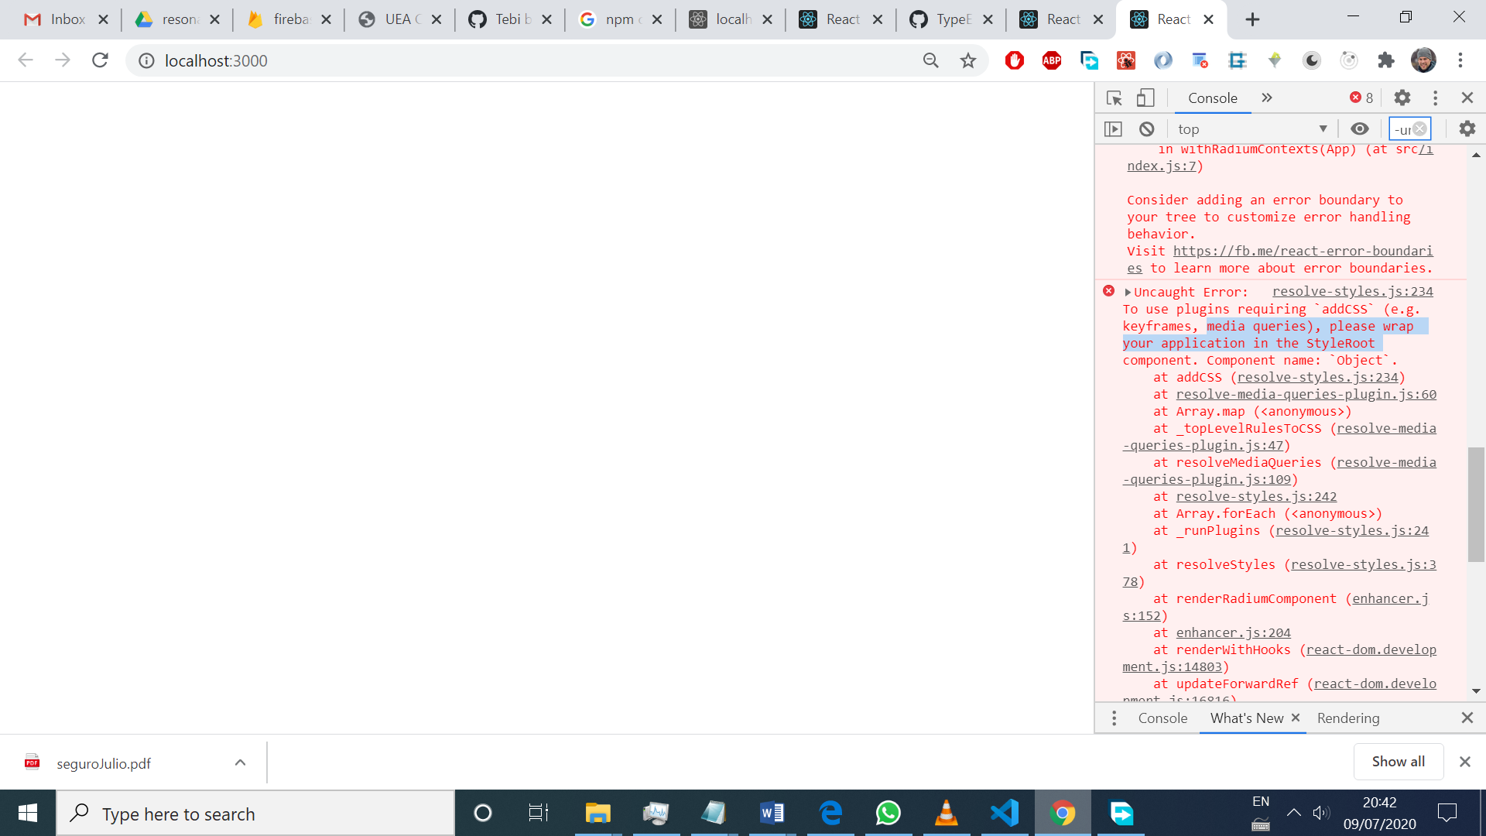

import Radium, { StyleRoot } from 'radium'; Radium is the default export and StyleRoot is a named export

return (

      <StyleRoot>

        <div className="App">

          <h1>Hi, I'm a React App</h1>

          <p className={classes.join(' ')}>This is really working!</p>

          <button

            style={style}

            onClick={this.togglePersonsHandler}>Toggle Persons</button>

          {persons}

        </div>

      </StyleRoot>

    );

Styled Components

* It uses tagged templates, which are `` double backticks. It’s a JS feature. It helps passing data as an argument to the function or method called, insead of using () parenthesis.

import styled from 'styled-components';

const StyledDiv = styled.div` // style.div return a react component, the style is just added inside the backticks

    width: 60%;

    margin: 16px auto;

    border: 1px solid #eee;

    box-shadow: 0 2px 3px #ccc;

    padding: 16px;

    text-align: center;

    @media (min-width: 500px) {

        width: 450px;

    }`;

 return (

        // <div className="Person" style={style}>

        <StyledDiv>

            <p onClick={props.click}>I'm {props.name} and I am {props.age} years old!</p>

            <p>{props.children}</p>

            <input type="text" onChange={props.changed} value={props.name} />

        </StyledDiv>

        // </div>

    )

* The rendered StyledDiv contains a class aumatically created by styled components

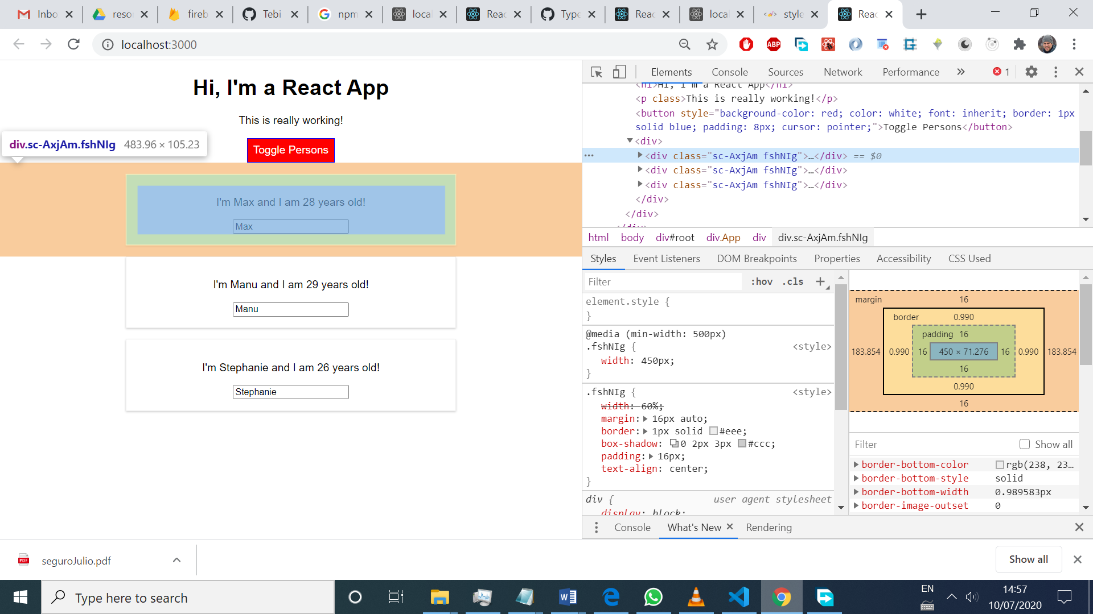

* The rules for that class can be seen in the html’s head

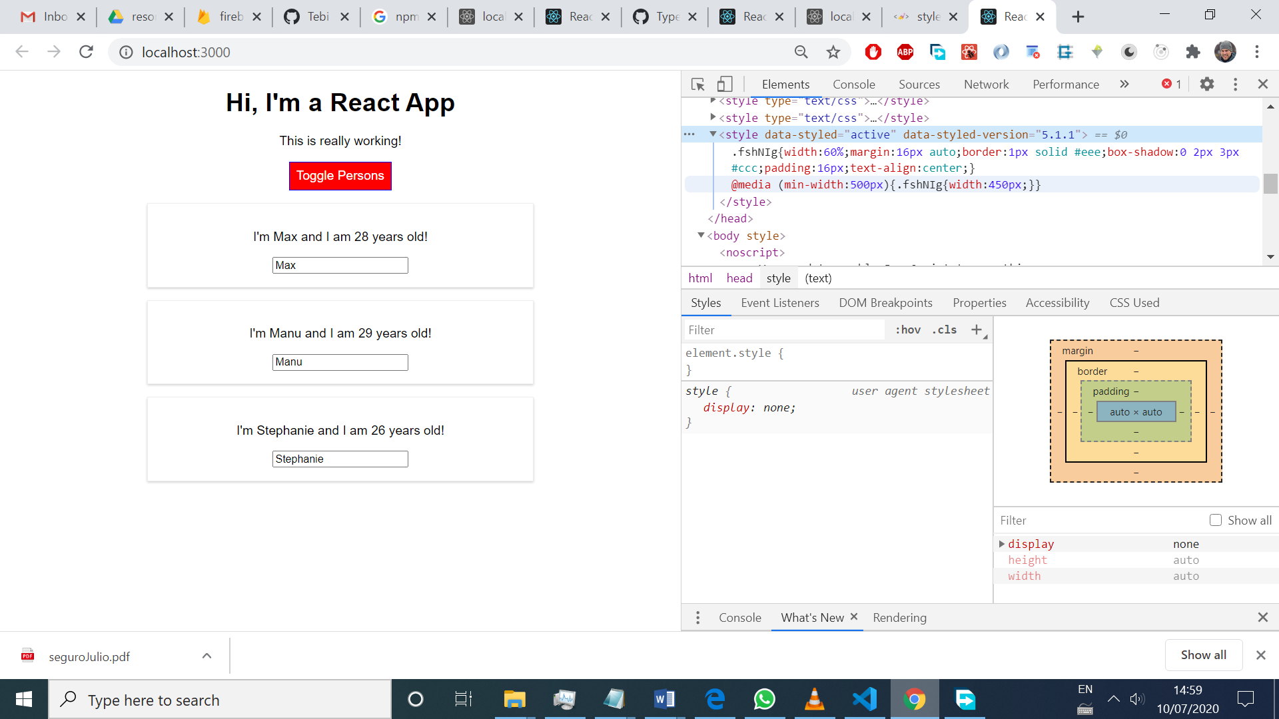

* With radium, inline styles are written and applied. With Styled components, inline styles are written, but applied with class instead (loosing the maximum specifity given by inline styles)
* To add dynamic state (reacting to a change of state and props) a prop should be passed to the StyledComponent:

<StyledButton alt={this.state.showPersons}

            onClick={this.togglePersonsHandler}>Toggle Persons</StyledButton>

const StyledButton = styled.button`

      background-color: ${props => props.alt? 'red' : 'green'};

      color: white;

      font: inherit;

      border: 1px solid blue;

      padding: 8px;

      cursor: pointer;

      &:hover {

        background-color: ${props => props.alt? 'salmon' : 'lightgreen'};

        color: black;

      }

    `;

* Styled components creates multiple classes, to cover all the conditions, and apply them dynamically
* BENEFIT of STYLED COMPONENTS: apply javascript logic inside CSS code :0!!
* DISADVANTAGE: large js files an poor autocompletion when writing rules

T

The best approach for styling is using CSS MODULES, which is the Angular way. Every css file is scoped to a single component.

* When importing classes from ‘App.css’, every class’s name inside the css file it’s transformed to a unique name, and added to an object. So classes is an object = {‘red’: ‘unique_red_name’, and so on}, that’s why we call classes.red to get the unique name in the js file.

.Button {

  background-color: green;

  color: white;

  font: inherit;

  border: 1px solid blue;

  padding: 8px;

  cursor: pointer;

}

.Button:hover {

  background-color: lightgreen;

  color: black;

}

.Button.Red {

  background-color: red;

}

.Button.Red:hover {

  background-color: salmon;

  color: black;

}

import classes from './App.module.css';

 let assignedButtonClasses =[classes.Button];

 if ( this.state.showPersons ) {

 assignedButtonClasses.push(classes.Red)

}

<button className={assignedButtonClasses.join(' ')}

            onClick={this.togglePersonsHandler}>Toggle Persons</button>

* To add dynamic styles, use if() checks, and add classes to an array and join them
* To sum it up: as many classes as states we want.

How to use css modules? If react-scripts version > 2, just name css files like this: .module.css t

If react-scripts version < 2, npm run eject, and modifiy webpack config files

Unit 6. Debuggin React Apps

* Dev tools/Sources gives access to js code the same way it’s written in the app. Even though is not the code that the app uses in the browser, it helps debugging placing break points, instead of using “debugger” inside the code.
* React dev tools are great. There’s a selector button, so we can select elements from the screen and see what component is. And add the state to the console for further inspecting

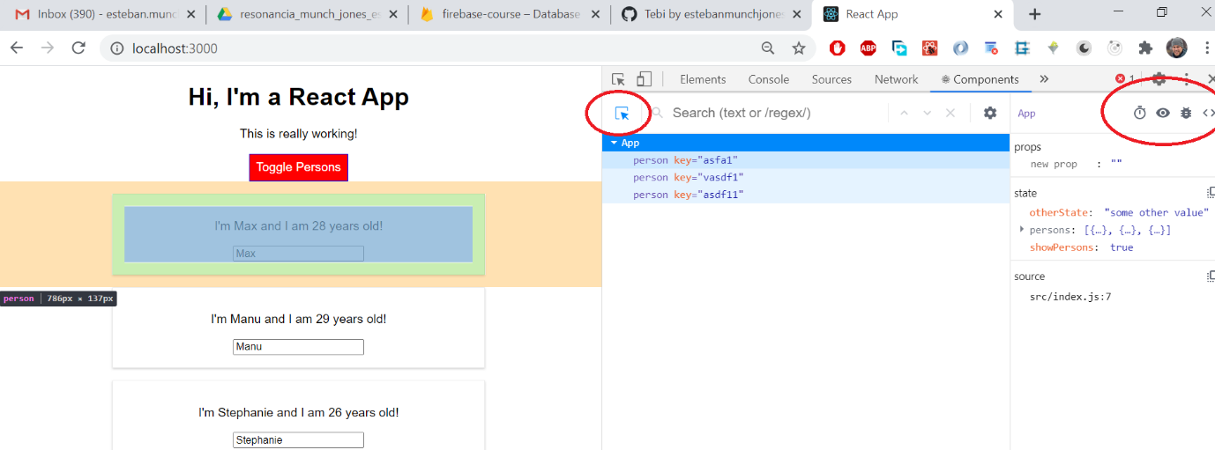

State values and props can be changed on the fly, and experiment the effects!

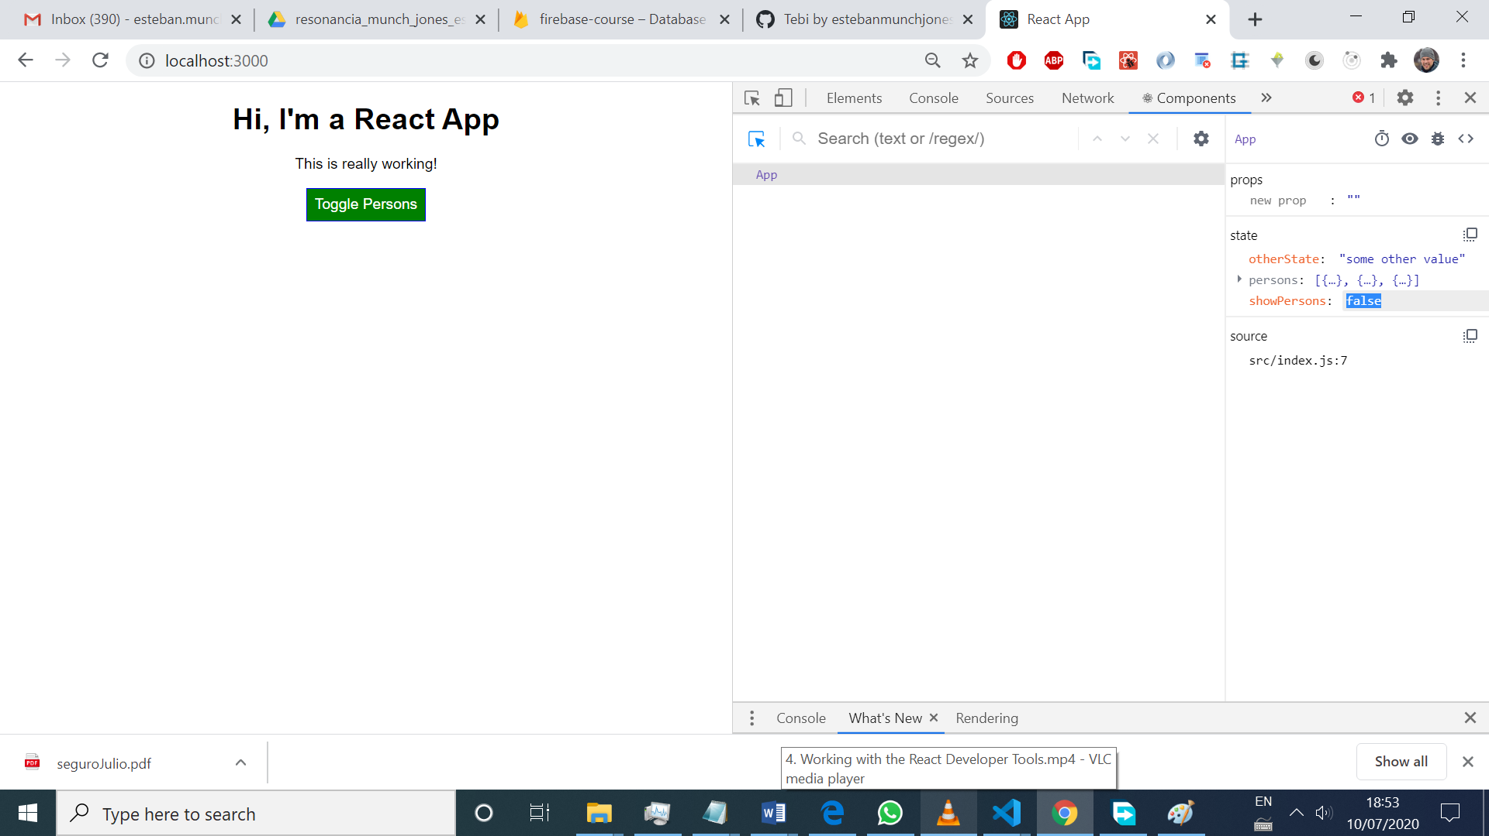

What if a Component might fail and not be rendered, and we can’t control that. It would nice to use the try and catch approach, but with a class method called componentDidCatch()

//the HOC

import React from 'react';

class ErrorBoundary extends React.Component {

    state = {

        hasError: false,

        errorMessage: ''

    }

    componentDidCatch = (error, info) => {

        this.setState({hasError: true, errorMessage: error});

    }

    render() {

        if (this.state.hasError) {

            return <h1>{this.state.errorMessage}</h1>

        } else {

            return this.props.children; //the children is already JSX, no need to wrappe it in a <div>

        }

    }

}

export default ErrorBoundary;

//Component that might fail

import React from 'react';

import classes from './Person.module.css';

import './Person.module.css';

const person = ( props ) => {

    const random = Math.random();

    if (random > 0.7) {

        throw new Error('random > 0.7');

    }

    return (

        <div className={classes.Person}>

            <p onClick={props.click}>I'm {props.name} and I am {props.age} years old!</p>

            <p>{props.children}</p>

            <input type="text" onChange={props.changed} value={props.name} />

        </div>

    )

};

export default person;

//App component

if ( this.state.showPersons ) {

      persons = (

        <div>

          {this.state.persons.map((person, index) => {

            return <ErrorBoundary  key={person.id}>

              <Person

                click={() => this.deletePersonHandler(index)}

                name={person.name}

                age={person.age}

                changed={(event) => this.nameChangedHandler(event, person.id)} />

            </ErrorBoundary>

            })

          }

        </div>

      );

* Important: this only woks on PRODUCTION and the key must be moved to the HOC (it’s now the outer most element)

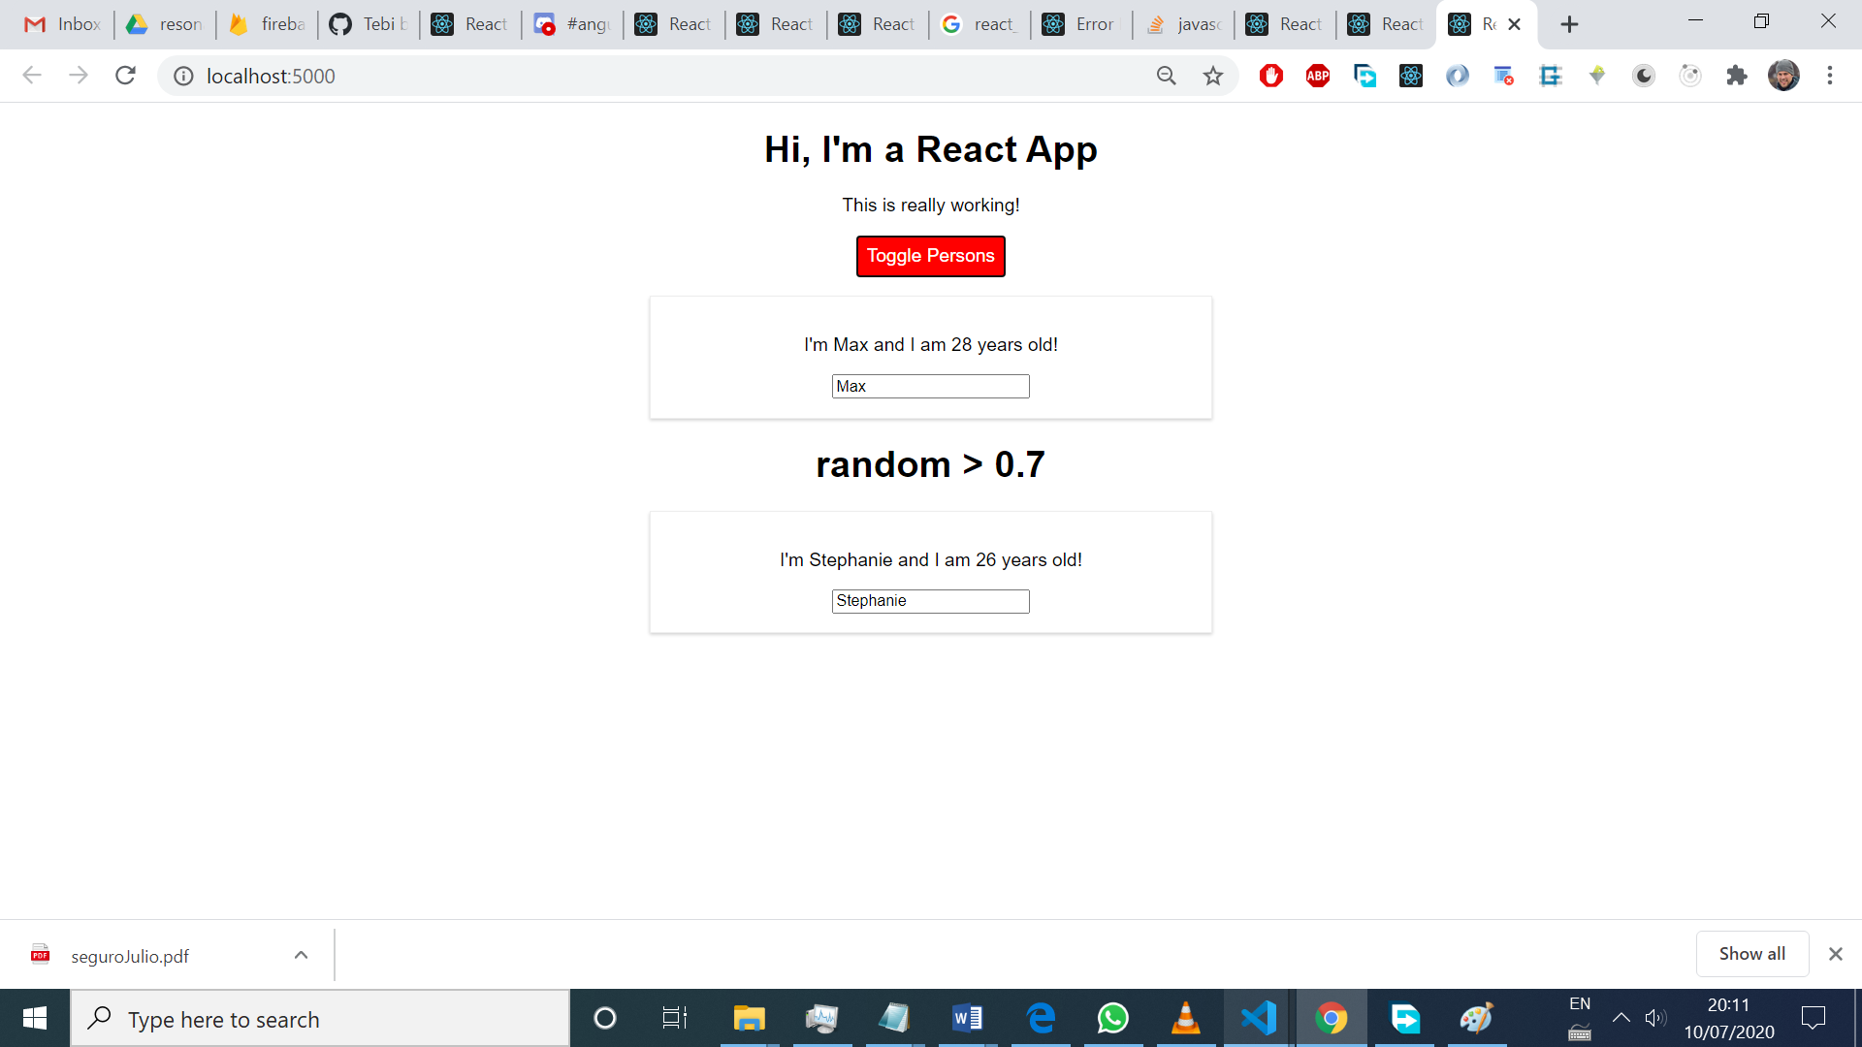

Unit 7: Diving deeper

* Stateful components should NOT render too much JSX, just a few components. So, if there’s too many html in render, move that to another component, that cares about the UI.
* A Stateful component, or a container is kind of a Service, that holds data and passes it to a component that cares for the UI
* A render function or a functional component can return a list of components (an array, like when you map an return a list of Person in Persons.js, [Person1, Person2, …), without having an outermost component (like a div wrapping a list of Person)
* RULE #1: containers should manage state and contain the methods that change it. The dumb components, have logic related to UI and most of the html
* RULE #2: use as many dumb components as possible (functional ones)

LIFECYCLE HOOKS

* In CLASS BASED components, super(props) is automatically called inside the constructor, and this.state called as well when using the modern way state= {}. BEST WAY!

CREATION

1. Constructor(): don’t cause side effects, like sending http request, or saving data to localStorage, to avoid unnecessary re-renders and affect performance
2. GetderivedStateFromProps() is rarely used, to update the state when the incoming props change
3. Render() return the JSX
4. ComponentDidMount() used to cause side effects. DON’T call this.setState() synchronously, (it causes an infinite loop of re-renders) just inside a then() block ASYNCHRONOULSY.

Examples:

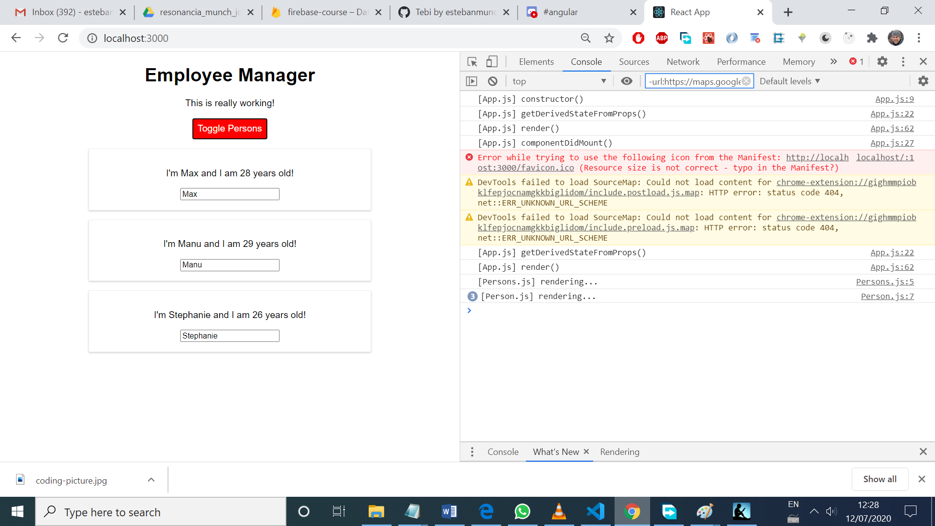

* There’s a chain of render methods, from the parent to the children.
* DON’T USE componentWillMount(). Use getDerivedStateFromProps() to adjust the state based on props after mounting, or use the constructor(), before mounting.
* The render() is just a rendering on the VIRTUAL DOM, and then React checks if the real DOM needs to be changed.

UPDATE (incoming props or state changes)

1. getDerivedStateFromProps(props,state) rarely used
2. shouldComponentUpdate(nextProps, nextState) can cancel the updating process and improve performance
3. getSnapshotBeforeUpdate(prevProps, prevState) don’t used to much. Used in last minute DOM operation, like getting the scrolling postion
4. componentDidUpdate() watch out for infinite loops when setting state here! Only do it asynchronously

example of updating Persons.js

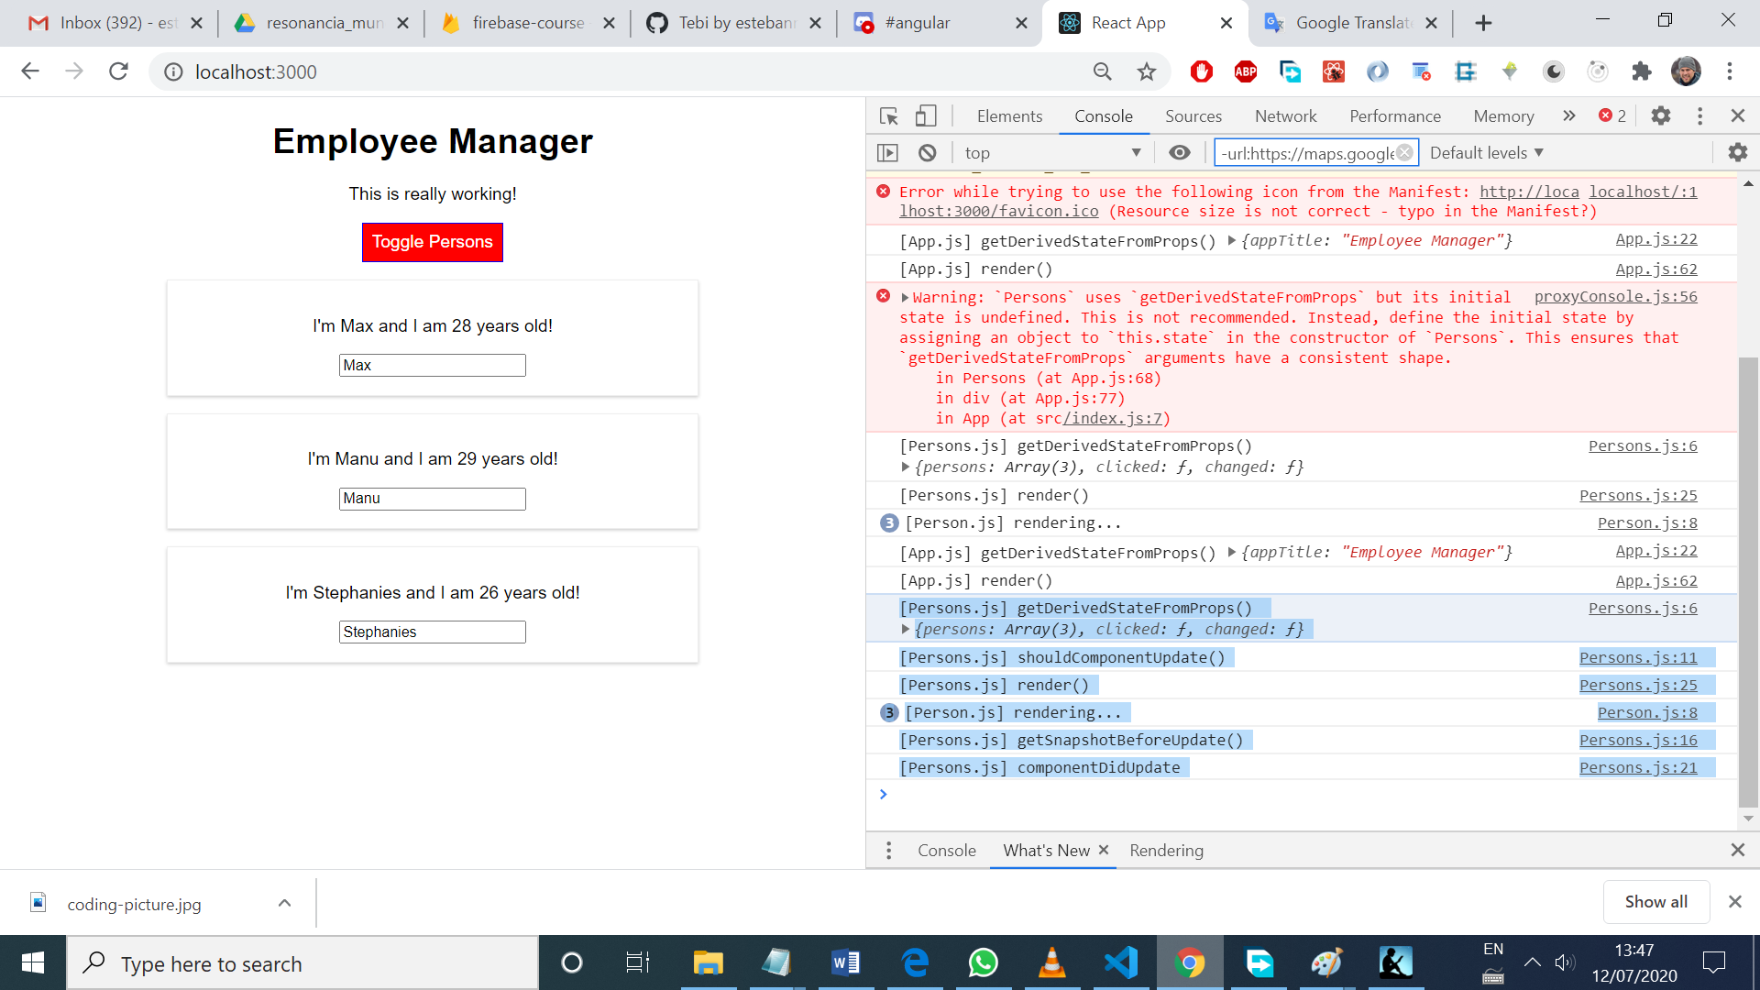

getSnapshotBeforeUpdate = (prevProps, prevState) => {

        console.log('[Persons.js] getSnapshotBeforeUpdate()');

        return {scrollPos: '200px'};

    }

    componentDidUpdate = (prevProps, prevState, snapshot) => {

        console.log('[Persons.js] componentDidUpdate', `snapshot: ${snapshot}`);

    }

* prevProps and prevState on getSnapshotBeforeUpdate and componentDidUpdate are not the same!!

FUNCTIONAL COMPONENTS

* useEffect() is like an componentDidMount and componentDidUpdtate combined, because it runs after every rendering, and it’s great for side effects, like http calls.
* To react to certain changes, like props.persons

useEffect(() => {

        console.log('[Person.js] useEffect()');

        setTimeout(() => {

            alert('persons changed')

        }, 2000)

    }, [props.persons]);

* To run the function just for the first cycle (upon creation), pass an empty string. The second argument of the useEffect functions always re-run if the props inside the square brackets change. If no props are defined, no re-run, so it only runs once, on the first cycle.

useEffect(() => {

        console.log('[Person.js] useEffect()');

        setTimeout(() => {

            alert('persons changed')

        }, 2000)

    }, []);

CLEAN UP WORK

* componentWillUnmount() in class based components and useEffect() with a function in a return
* case 1: empty array passed: runs just like componentWillUnmount, before it’s unmounted

 useEffect(() => {

        console.log('[Cockpit.js] useEffect()');

        setTimeout(() => {

            alert('persons changed')

        }, 2000);

        return () => {

            console.log('[Cockpit]useEffect() clean up work');

        }

    }, []);

* case 2: no array passed at all. It doesn’t run the first cycle, and the keeps running on every cycle

useEffect(() => {

        console.log('[Cockpit.js] useEffect()');

        const timer = setTimeout(() => {

            alert('persons changed')

        }, 2000);

        return () => {

            console.log('[Cockpit]useEffect() clean up work');

            clearInterval(timer);

        }

    });

Avoid Re-Rendering

* an if check can be done to avoid re-rendering of Person.js when the cockpit is removed

//in Person.js

shouldComponentUpdate = (nextProps, nextState) => {

        console.log('[Persons.js] shouldComponentUpdate()');

        if (this.props.persons == nextProps.persons) {

            return false;

        } else {

            return true;

        }

    }

The if check Works because persons object and array were cloned when manipulated, so they’re different references

//in App.js

 const person = {

      ...this.state.persons[personIndex] // clone the person object

    };

    // const person = Object.assign({}, this.state.persons[personIndex]);

    person.name = event.target.value; //modify it

    const persons = [...this.state.persons];//clone the persons array

    persons[personIndex] = person; //push the cloned object in the cloned array

* great tool to see what components are being rendered in the REAL DOM. Rendering => Enable paint flashing.

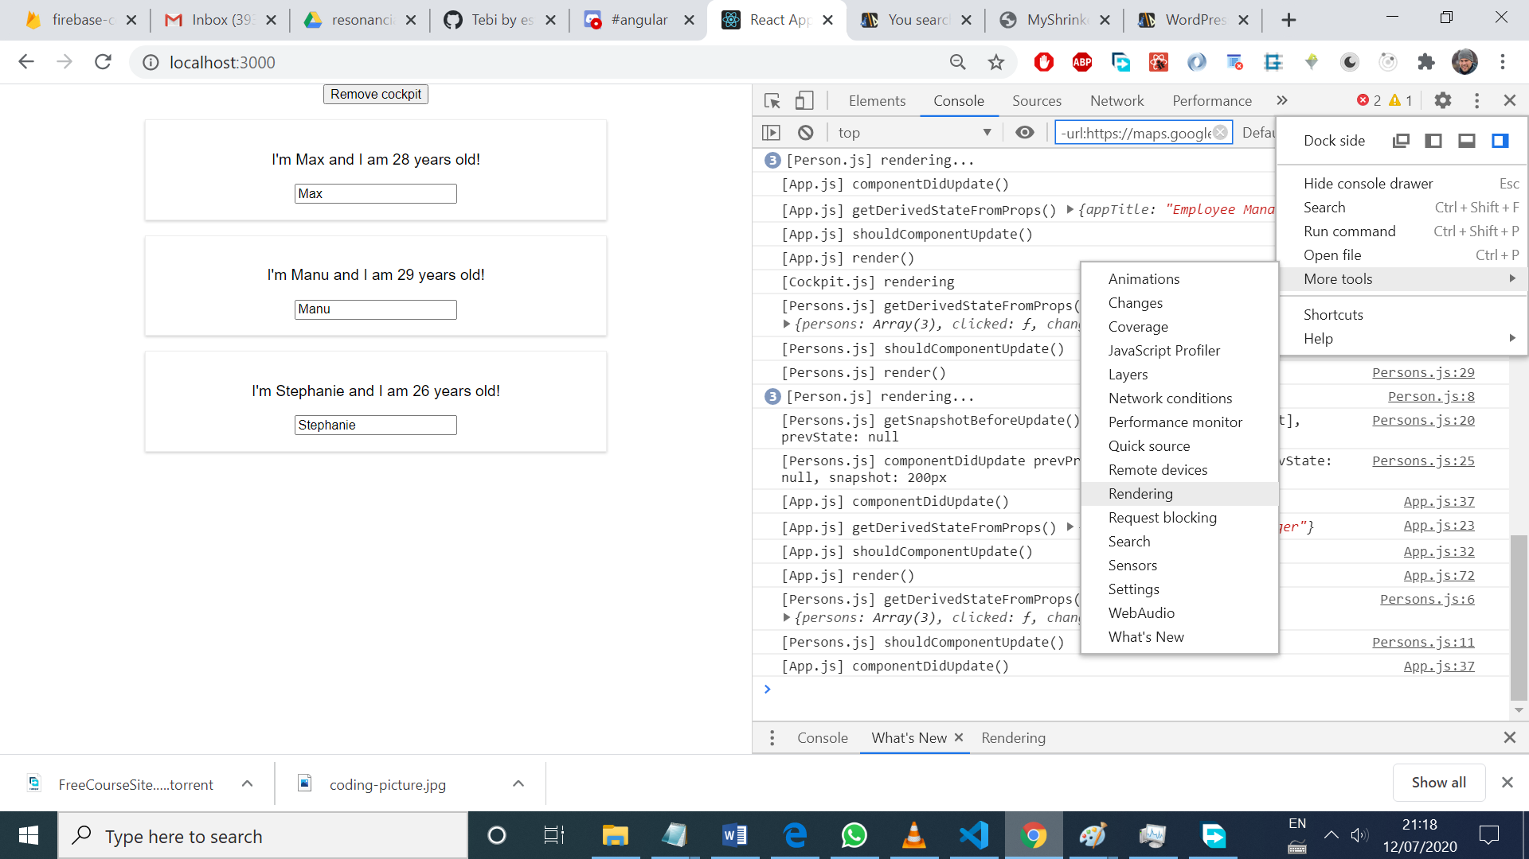

* Avoiding re-rendering with functional components it’s EASIER:

export default React.memo(cockpit);

//with this HOC, the render method executes if the incoming props changed!!

* WARNING: don’t add shouldComponentUpdate or React.memo() to all components, because it’s more code to run on every cycle, and slows the app down.
* To apply React.memo functionality to class based components:

class Persons extends React.PureComponent {}

only re-renders if the any incoming props change. I’d have to have a super big shouldComponentUpdate with tons of if checks to have the same functionalty. With PureComponents, a shouldComponentUpdate with all the if checks come built in

RENDERING PROCESS

* Accessing the REAL DOM is really slow!
* Process: OLD virtual DOM compared to new Virtual DOM. If differences, then that the parts changed in the REAL DOM. If inspecting in dev tools, the elements changed in the REAL DOM flashes (like the ngTouched classes in forms in Angular).
* React.Fragment is a HOC that simply return the children. Is the same as a custom Auxuliary HOC

Const auxiliary = (props) => props.children;

Export default auxiliary;

HOC

* They’re components that wrap other components and give some functionality, like this one, which adds a div with a class
* WAY #1 (for changing the JSX, the styles)

import React from 'react';

const withClass = (props) => <div className={props.style}>{props.children}</div>;

export default withClass;

 return (

        <WithClass style={classes.Person}>

            <p onClick={props.click}>I'm {props.name} and I am {props.age} years old!</p>

            <p>{props.children}</p>

            <input type="text" onChange={props.changed} value={props.name} />

        </WithClass>

    )

* WAY #2 (for adding some js logic)

import React from 'react';

const withClass = (WrappedComponent, style) => {

    return props => (

        <div className={style}>

            <WrappedComponent {...props}/>

        </div>

    )

};

export default withClass;

export default withClass(person, classes.Person);

//make sure to spread props inside the WrappedComponent!!!

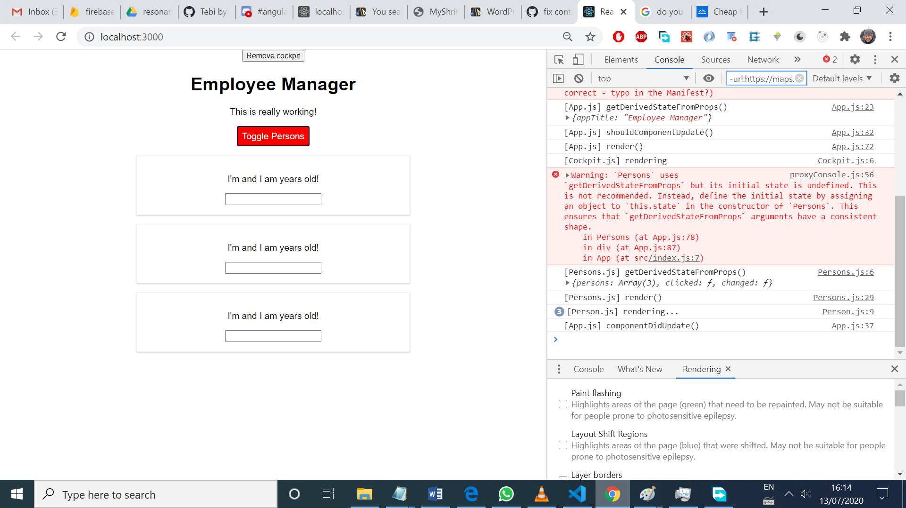

Explanation about spreading props in the HOC: importing Person from ‘Person.js’ in Persons.js file, what’s imported is

export default withClass(person, classes.Person);

So person now is wrapped by withClass function, which accepts props:

const withClass = (WrappedComponent, style) => {

    return props => (

Which should be forwarded to the Wrapped component now

<WrappedComponent {...props}/>

SetState()

Want to update the state based on a previous state?? setState is asynchronous, so it can be called later on, and other function could change the state in the meantime. Use this:

this.setState((prevState, props) => {

      return {

        persons: persons,

        inputCounter: prevState.inputCounter + 1

      }

    });

PropTypes

* To check the types of the props:

import PropTypes from 'prop-types';

person.propTypes = {

    age: PropTypes.number

}

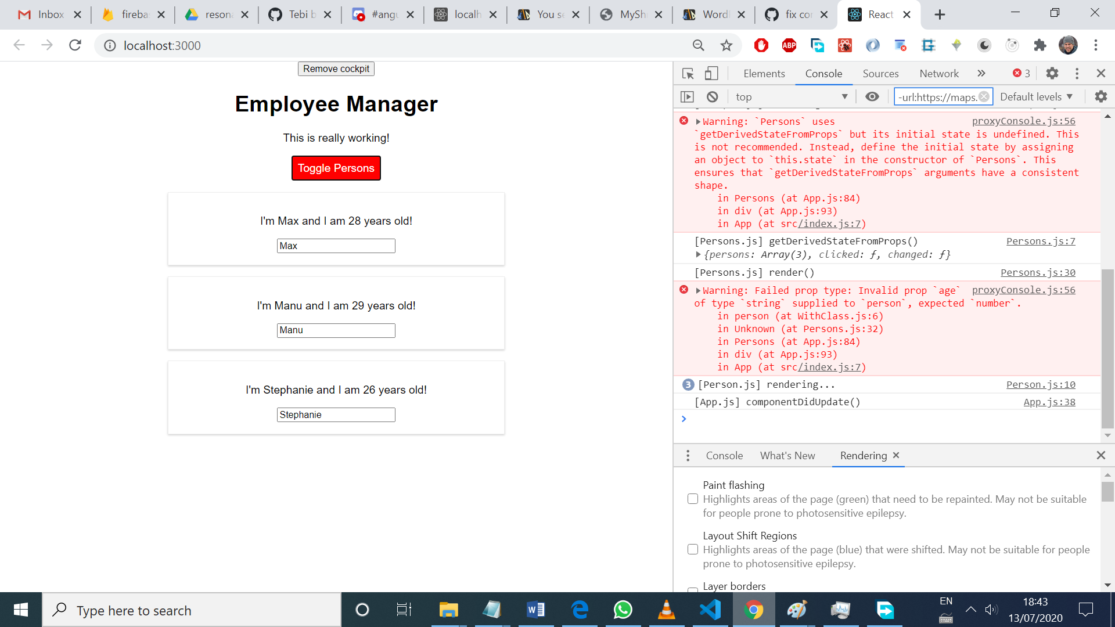

Targeting specific Html elements

* Instead of using document.getElementById(‘input1’), a Ref can be used inside the component. In Angular, use ViewChild and # inside the template
* WAY #1:

const person = (props) => {

    let elementRef = '';

useEffect(() => {

        elementRef.focus();

    },[]);

    console.log('[Person.js] rendering...');

    return <React.Fragment>

        <p onClick={props.click}>I'm {props.name} and I am {props.age} years old!</p>

        <p>{props.children}</p>

        <input

        type="text"

        onChange={props.changed}

        value={props.name}

        ref={(elRef) => elementRef = elRef }/>

//this.elementRef can be used in classed based components,

Without the need of defining that variable beforehand inside the class

    </React.Fragment>

};

* WAY #2:

const person = (props) => {

    let elementRef = React.createRef(); || React.useRef(null) for functional components

//for classed based components, add

constructor(props){

super(props);

this.elementref = React.createRef();

}

    useEffect(() => {

        elementRef.current.focus();

    },[]);

    console.log('[Person.js] rendering...');

    return <React.Fragment>

        <p onClick={props.click}>I'm {props.name} and I am {props.age} years old!</p>

        <p>{props.children}</p>

        <input

        type="text"

        onChange={props.changed}

        value={props.name}

        ref={elementRef}/>

    </React.Fragment>

};

Context API

* It’s an generaly an object (or array, number, string) that can be shared across the boundaries we want (e.g, the whole app). It’s used to ship props down the component’s tree, to avoid passin props down the usual way
* It’s better to initialize the object with the variables we wanna use, to have better autocompletion.
* The object should wrap all the Components that want to access it.
* The app still uses this.state to manage the state, and the re-render only happens when state or props change. But as the value prop passed to AuthContext.Provider JSX component is a props, implicitly, when the incoming props of context changes, a re-render is triggered, so some components inside the Provider may render when we don’t want to
* AuthContext.Consumer, takes a function inside it, that accepts the contenxt object as an argument
* MAIN GOAL: SKIP PASSING PROPS IN LONG CHAIN OF COMPONENTS.

//create the AuthContext object

import React from 'react';

const authContext = React.createContext({ //properties defined here for better autocompletion

    isAuth: false,

    login: () => {}

});

export default authContext;

//load the object with data in App.js

return (

        <div className={classes.App}>

          <AuthContext.Provider value={{isAuth: this.state.isAuth, login: this.login}}>

            <button onClick={() => this.setState({showCockpit: false})}>Remove cockpit</button>

            {this.state.showCockpit? <Cockpit

            title={this.props.appTitle}

            personsLength={this.state.persons.length}

            showPersons={this.state.showPersons}

            toggled={this.togglePersonsHandler}/> : null}

            {persons}

          </AuthContext.Provider>

        </div>

    );

    // return React.createElement('div', {className: 'App'}, React.createElement('h1', null, 'Does this work now?'));

  }

//consume the object in Person.js

return (

        <React.Fragment>

            <AuthContext.Consumer>

                {(context) => {

                    return context.isAuth? <p>You're logged in</p> : <p>Please, login</p>

                }}

            </AuthContext.Consumer>

            <p onClick={props.click}>I'm {props.name} and I am {props.age} years old!</p>

            <p>{props.children}</p>

            <input

            type="text"

            onChange={props.changed}

            value={props.name}

            ref={elementRef}/>

        </React.Fragment>

    )

LIMITATION of <AuthContext.Consumer> WAY: context can only be accessed in the return block. If I need it in componentDidMount, there’s no way.

BEST WAY CONTEXT API React 16.6

//Functional components

const authContext = useContext(AuthContext); //the authContext is a component variable now.

 return (

        <React.Fragment>

            {authContext.isAuth? <p>You're logged in</p> : <p>Please, login</p>}

            <p onClick={props.click}>I'm {props.name} and I am {props.age} years old!</p>

            <p>{props.children}</p>

            <input

            type="text"

            onChange={props.changed}

            value={props.name}

            ref={elementRef}/>

        </React.Fragment>

    )

//Class based components

static contextType = AuthContext;

this.context

//this variable is automatically generated by React inside the class

Unit 8: Real App the burger builder

* If a function just returns props.children, the ‘ import React from react’ is no needed because there isn’t any JSX involved. If there aren’t any angle brackets <>, there’s no JSX involved.
* Inside the Components and Container folder in the project, divide them into subfolders by feature, like Burger, Checkout, etc
* The stateful component should have just the methods to change the state, and no logic to deal with UI. That logic should be done in presentational (dumb components)
* When passing methods via props, and there’s a need to set the argument of the method in the chain of props, just use an anonymous function at any point in the chain of props, and add the argument that lives in that part of the chain

//BuildControls.js

const controls = [

    {label: 'Cheese', type:'cheese'},

    {label: 'Salad', type:'salad'},

    {label: 'Bacon', type:'bacon'},

    {label: 'Meat', type:'meat'}

]

return <BuildControl

            key={control.label}

            label={control.label}

//anonymous function here

            added={() => props.ingredientAdded(control.type)}

            removed={() => props.ingredientRemoved(control.type)}

            disabled={props.disabled[control.type]}/>

//BuildControl.js

const buildControl = (props) => (

    <div className={classes.BuildControl}>

        <div className={classes.Label}>{props.label}</div>

        <button className={classes.Less} onClick={props.removed} disabled={props.disabled}>Less</button>

        <button className={classes.More} onClick={props.added}>More</button>

    </div>

);

* Make sure to place if checks inside the componenDidUpdate when making http requests, otherwise there an infinite cycle of requests

//componentDidUpdate() { loadPost()}

loadPost = async () => {

        if (!this.state.loadedPost || (this.state.loadedPost && this.state.loadedPost.id != this.props.match.params.id)) {

            const fullPost = await axios.get('/posts/' + this.props.match.params.id);

            this.setState({loadedPost: fullPost.data})

        }

    }

* For interceptors, they affect all requests by default and need to have return statement, otherwise, they block the request

axios.interceptors.request.use((request) => {

    console.log(request);

    return request;

}, error => {

    console.log(error);

    return Promise.reject(error);// it fires when there’s no internet cnx

});

axios.interceptors.response.use((response) => {

    console.log(response);

    return response;

}, error => {

    console.log(error); //it fires when the url enpoint is wrong

    return Promise.reject(error);

});

* Requests can be configured globally like this

axios.defaults.baseURL = 'https://jsonplaceholder.typicode.com';

axios.defaults.headers.common['Authorization'] = 'AUTH TOKEN';

axios.defaults.headers.post['Content-Type'] = 'aplication/json';

* An instance of axios can be create and then used in a specific part of the app. E.g: just in one parte of the app I want to have baseURL=’some url’ . All the interceptors must be added in the instance if intended to be used in the instance.
* The price of the burger should be calculated in the server, because the user can manipulate the code in the front-end, like usual.
* Would be nice to show response errors. So, the way is creating a HOC that is a function, and takes the axios instance to intercept the request at the HOC level, and if there’s an error, show the Modal with the error.
* In withErrorHandler, clean the interceptors of the axios instance, because it’s a memory leak and can lead to errors in the worst case. It’s like ngOnDestroy(){ unsubscribe..}

return class extends Component {

        constructor(props) {

            super(props);

            this.state = {

                error: null

            };

            this.reqInterceptor = axios.interceptors.request.use(req => {

this.setState({error: null}) //clean the error when requesting

                return req;

            });

            this.resInterceptor = axios.interceptors.response.use(res => res, error => {

                this.setState({error: error}); //getting error in the response

            });

        }

        errorConfirmedHandler = () => {

            this.setState({error: null}) //fired clicking the backdrop

        }

        componentWillUnmount() {

            console.log('componentWillUnmount', this.resInterceptor, this.reqInterceptor);

            axios.interceptors.request.eject(this.reqInterceptor);

            axios.interceptors.response.eject(this.resInterceptor);// destroy the interceptors upon unmounting

        }

Section 11 : Routing

* When using react-router and react-router-dom, STEP #1: Wrap the component tree with the BrowserRouter component

<BrowserRouter>

        <div className="App">

          <Blog />

        </div>

      </BrowserRouter>

* Each component loaded via routing should keep their own state, and data between these components can be passed via route params, or with just avoid routing params by using a global state (Redux or hooks) THE BEST WAY
* For navs, instead of using <a href=’/’ > use <Link to=’/’ >Home</Link>, <Route path=””>. In Angular, is routerLink=”/”, and <router-outlet> to load new components. The router are then handled in app-routing.module.ts file. Angular is cleaner.
* When using <Link>, react will create the anchor tag and prevent the default which is to ask the server a new html file
* With react-router, the route info (params, hash, etc) is passed to the loaded component via props.match. location and history also came via props as well. Use withRouter HOC to access those props deep in the component tree
* Router render Posts via routing, and then Posts renders Post inside. How can I access the route properties inside Post?? Option #1: pass the match params from Posts to Post via props, like match={this.props.match}. Option #2: use withRouter HOC, and wrap Post, like this withRouter(Post).
* For <Link to=’/new-post’ > is always treated as an absolute path. Want to link to a relative path? Use props.match like this to=this.props.match.url + ‘/new-post’ .
* In Angular relativeTo=”” is used

In Angular, to get the params, just inject private route: ActivatedRoute

//and the snapshot as well, to get the first url

this.route.params

      .subscribe((params: Params) => {

          this.id = +params['id'];

          this.editMode = params['id'] != null;

          this.initForm();

        })

* Want to style the active link in the nav? Use NavLink, which add class=”active” to the active link. Make sure to add the ‘exact; property to the NavLink, to have exact match and not have all the links active because all them match the / route.
* The Angular way to style the active links:

<li routerLinkActive="active"><a routerLink="shopping-list">Shopping List</a></li>

* Wanna use a custum active class? Just add activeClassName=”my-active-class’
* Wanna use inline style instead of classes? Use activeStyle={{ color: red}}
* From Posts component, clicking a Post and navigate to that Post, each Post component can be wrapped with the Link component.
* Want to extract search params and hash segments?

componentDidMount() {

const query = new URLSearchParams(this.props.location.search);

for (let param of query.entries()) {

console.log(param); // yields ['start', '5']

}

}

* Want to extract a fragment #?

You can simply access props.location.hash .

* Wanna load just one route at a time? Just wrap the routes with <Switch> component
* The order of the routes matters, because they’re read from top to botton, and if there’s a Switch, it will only render the first route it matches the path
* Wanna navigate programmatically? Use this.props.history.push( ‘/new-path’). In Angular was this.router.navigate([‘/new-path’]);
* Want nested routes? Avoid using ‘exact’ property on / route, and put that route at the bottom of the routes list. TIP: if the exact property is set, then, the NESTED routes doesn’t render.
* For NESTED ROUTES, append the current url to the route:

<Route path={this.props.match.url + '/:id'} exact component={FullPost} />

* In Angular, nested routes are declared as children

const routes: Routes = [

  { path: '',       component: RecipesComponent, //lazyloading requires to have '' path because the RecipesModule is loading when already in '/recipes'

    canActivate: [AuthGuard],

    children: [

        {path: '',           component: RecipeStartComponent},

        {path: 'new',        component: RecipeEditComponent},

        {path: ':id',        component: RecipeDetailComponent, resolve: [RecipesResolverService]},

        {path: ':id/edit',   component: RecipeEditComponent,   resolve: [RecipesResolverService]}

    ]

  }

];

And adding nested <router-outlet> tags inside the component template

* If a FullPost was loaded via childRouting, the, if the http request to server is done in componentDidMount(), it’s not gonna be called, but componentDidUpdate does, because the props.match.url changed. So use componentDidUpdate for http calls inside the child when it was loaded using child routing
* Wanna redirect inside the Switch block?

 <Redirect from="/" to="/posts"/>

* In Angular: path: ‘/’ redirectTo=”/posts”
* Wanna redirect outside the <Switch> block? Then conditionaly render a <Redirect to=”/” /> inside the component conditionaly (after setting the state redirect=true, for example):

let redirect = null;

if (this.state.submited) {

redirect = <Redirect to="/posts" />

 }

        return (

                {/* {redirect} */}

Some more JSX of the component

* So, the above way is: hold state, and conditionaly render <Redirect> to be redirected after rendering it. I still prefer this.props.history.push( ‘/new-path’). The difference between them? Redirect replaces the current page in the stack (no backwards allowed then) and push puts a new page on the stack, so the user can go back
* Using this.props.history.replace(), the result is the same as <Redirect> (no backwards)
* As a <Route> is a component, a GUARD is just rendering that <Route> component conditionally. That’s it :0

{this.state.authenticated ? <Route path="/new-post" component={NewPost} />: null }

* Guard in Angular:

canActivate(route: ActivatedRouteSnapshot, state: RouterStateSnapshot):

        boolean

        |UrlTree

        | Promise<boolean | UrlTree>

        | Observable<boolean | UrlTree> {

            return this.authService.user.pipe(

                take(1),

                map(user => {

                    const isAuth = !!user;

                    if (isAuth) {

                        return true;

                    } else {

                        return this.router.createUrlTree(['/auth']);

            }))

    }

}

* Strategy to handle UNKNOWN routes:
* #1: <Redirect from=’/’ to=’/posts’ > at the end of all the Routes. OR
* #2: <Router component={404Component}> at the end of all the Routes. (Without a path property)

In Angular   { path: '**', redirectTo:'posts'}

* LazyLoading works using the default webpack config that comes with create-react-app and react-router v.4
* In Angular

const appRoutes: Routes = [

    { path: '', redirectTo: 'recipes', pathMatch: 'full'}, //pathMatch: 'full', otherwise it redirects avery route, since all of them start with '/'

    { path: 'recipes', loadChildren: () => import('./recipes/recipes.module').then(m => m.RecipesModule) }, //the load children asks: please, only load RecipesModule when the path recipes is accessed

    { path: 'auth', loadChildren: () => import('./auth/auth.module').then(m => m.AuthModule)},

    { path: 'shopping-list', loadChildren: () => import('./shopping-list/shopping-list.module').then(m => m.ShoppingListModule)},

    { path: '**', redirectTo:'recipes'}

];

* In Angular, I only import the modules when I need them, asynchronously.
* In React, is the same, but instead of modules, components are imported asynchronously
* #1 WAY (for SSR as well) A dynamic import passed as an anonymous function as an argument

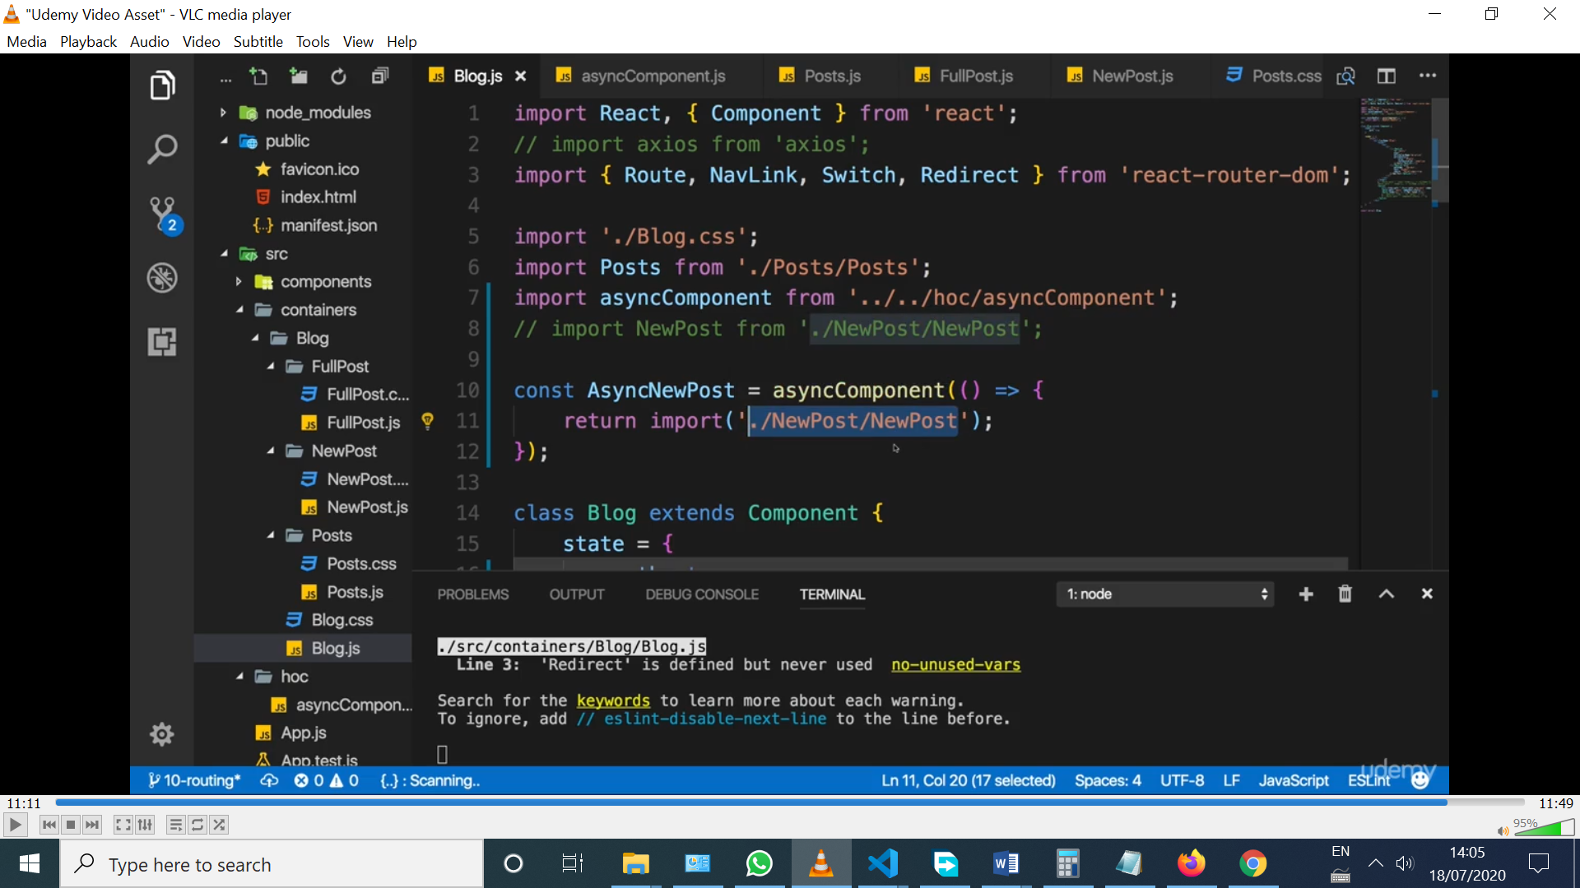

And asyncComponent it’s an HOC component:

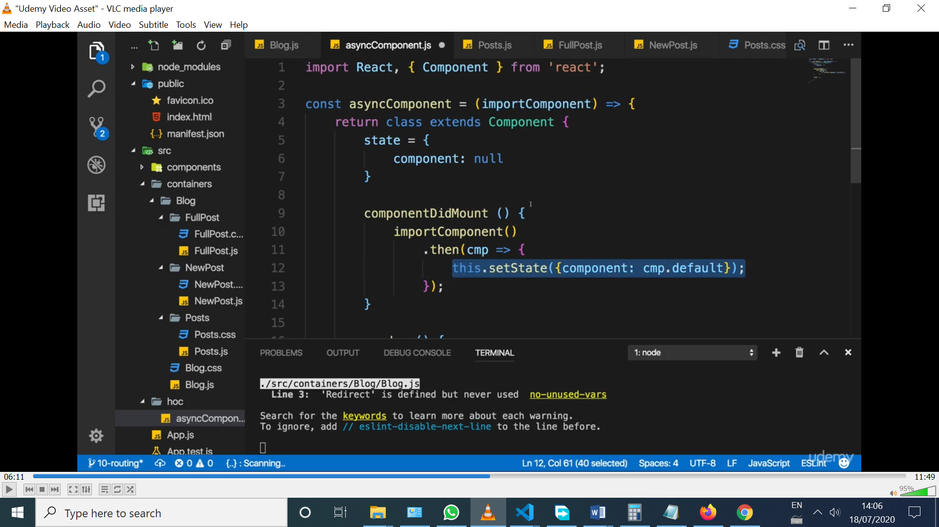

The import() anonymous function passed as importComponent, is a promise.

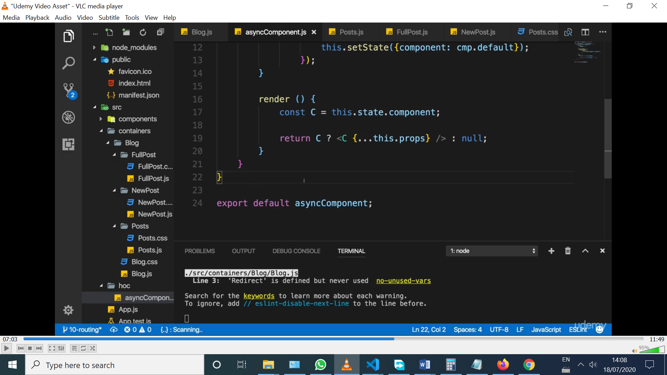

* When the route /new-posts is hit, then, asyncComponent variable is called, and the function inside it is triggered (the import async function).
* #2WAY, for React v.16 and above (not for SSR)
* The dynamic import doesn’t work for named exports {}, but it does for default ones.
* React.lazy() doesn’t work on SSR

const Posts = React.lazy(() => import('./Posts/Posts'));

<Suspense fallback={<div>Loading...</div>}>

    <Posts />

</Suspense>)

OR can be use on ternary expressions

{this.state.showPosts? <Suspense fallback={<div>Loading...</div>}>

    <Posts />

</Suspense> : null);

}

* LazyLoading only makes sense for huge components, otherwise is an overkill or can slow down the app.
* Wanna serve your app from subdirectory, example.com/my-app? Modify BrowserRouter

 <BrowserRouter basename=’/my-app’ >

Section 12

* Just npm I react-router-dom (it already has react-router as a dependency)

 <Switch>

              <Route path="/orders" component={Orders} />

              <Route path="/checkout" component={Checkout} />

              <Route path="/" exact component={BurgerBuilder} />

            </Switch>

* Using Switch, the exact property in not needed because only one route is loaded at a time.
* Props.match.path should be used for constructing paths inside nested routes.
* How to pass the ingredients from Checkout to the nested Route ContactData, just use render in the Route and pass the props ;)

 <Route

                path={this.props.match.path + '/contact-data'}

                render={() => <ContactData ingredients={this.state.ingredients} totalPrice={this.state.totalPrice} />} />

* Using render to load the component, {…props} can be distributed in ContactData to pass it the props.match.history needed to do redirects inside ContactData. Other way is to wrap export withRouter(ContactData) inside the ContactData.js file
* Wanna pass data between components renders via routing? Use search params:

//BurgerBuilder.js

purchaseContinueHandler = async () => {

        const queryParams = [];

        for (let i in this.state.ingredients) {

            queryParams.push(encodeURIComponent(i) + '=' + this.state.ingredients[i]); // [‘salad=1’, ‘meat=2’]

            //encodeURIComponent() is not neccesary here, but useful for more complex stuff

        }

        queryParams.push('totalPrice=' + this.state.totalPrice);

        const queryString = queryParams.join('&')

        this.props.history.push({

            pathname: '/checkout',

            search: '?' + queryString

        });

    }

//Checkout.js

 componentDidMount() {

        const query = new URLSearchParams(this.props.location.search);

        const ingredients = {};

        let totalPrice = null;

        for (let param of query.entries()) { //param is like ['meat', '1']

            if (param[0] === 'totalPrice') {//filter the Price, that comes with the ingredients

                totalPrice = +param[1]; //param[1] is converted into a number with + sign

            } else {

                ingredients[param[0]] = +param[1];

            }

        }

        this.setState({

            ingredients: ingredients,

            totalPrice: totalPrice

        });

    }

* For components that are rendered via child routing, check if the some logic should go on componentDidUpdate or componentDidMount(like a post :id) selected from a posts list.

Section 13 –Forms

* Prop names should be lower case, like inputtype instead of inputType
* In Angular, TDA the form is written in the template, and then an object is inferred from it and then added to the model for validation and manipulation.
* In Angular, the Reactive forms create an object in the model, and then links each part of the object to each part of the form in the template.
* In React; the form is created in the state, converted to an array, mapped, and then converted to JSX. Two way data binding must be manually created with onChange listeners to change the state, and then the value shown is picked up from the state.
* Wanna update the state, and there are nested objects? Make sure you clone nested objects as well, a deep cloning. How to clone?

const updatedOrderForm = {...this.state.orderForm }

const updatedFormElement = {...updatedOrderForm[inputIdentifier]}

// updatedFormElement = {  elementType: 'input',

                elementConfig: {

                    type: 'text',

                    placeholder: 'Your country'

                },

                value: '',

                validation: {

                    required: true

                },

                valid: false,

                touched: false

}

* How to submit the form?

 <form onSubmit={this.orderHandler}>

 event.preventDefault();

* Wanna loop in a object? Use for let name in names
* Wanna loop in an array? Use for let name of names
* Having the shape of form in the state, makes it easy to add new fields at runtime, dynamically.
* Validation in Angular is easy

//Reactive Forms

'name': new FormControl(ingredient.name, Validators.required),

And ng-valid, ng-pristine, ng-touched classes are added at runtime

//TDA Forms

<div class="col-sm-2 form-group">

                    <label for="amount">Amount</label>

                    <input

                    type="number"

                    id="amount"

                    class="form-control"

                    ngModel

                    name="amount"

                    required

email or number, etc

                    pattern="^0*[1-9]\d*$">

                </div>

Section 14-Redux

* Passing data from BurguerBuilder.js to Checkout.js was done via search params, because they were loaded via routing. It would be nicer to store the ingredients in a global object. Talking between components, if there’s no routing, is about going up and setting complicated connections between components. NOT the WAY. Redux to the rescue.
* Reducers: they execute just synchronous code, no side-effects or asynchronous code.
* In the example app, redux-basics.js is just decouple from the app and is run on node
* A Store needs a reducer (which is the result of a combination of multiple ones) to be created
* The state could be an object, number, string, etc
* The store.subscribe() runs every time the state changes
* Do you wanna create a folder in the right spot in VS code? Just click on a file file, and the folder will be created on top. Clicked App.js to create store folder

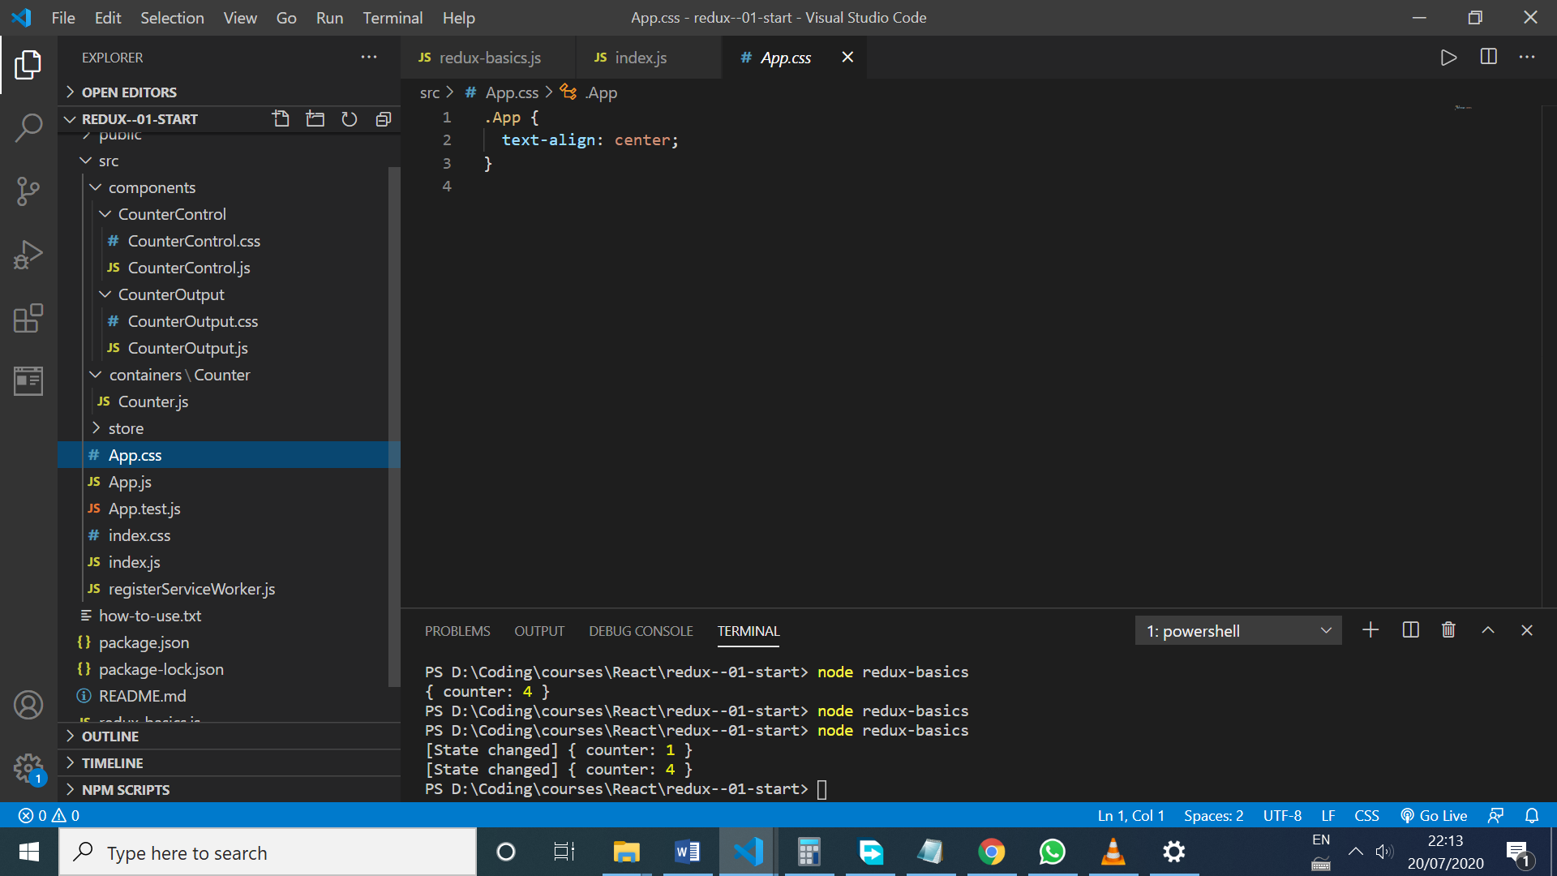

* How to connect react and redux? With a package react-redux
* Then the object is provided, like with Context API

<Provider><App /></Provider>

* And then pass the store object as a prop

<Provider store={store}><App /></Provider>

* To consume the store, use a function that returns a HOC, called ‘connect’ from ‘react-redux’ package. The slice we want in a component, and the actions we want to dispatch from it can be defined
* When using switch statement, there’s no need to add breaks, because the return breaks the switch
* One way to clone an object is Object.assign({}, state)

Cloning and array and adding a new element

const updatedResults = [...state.results];

            return {

                ...state,

                results: updatedResults.push(state.counter)

OR

* Example of deleting stored results

return <li key={index} onClick={() => this.props.onRemoveResult(index)}>{result}</li>

* I passed the index inside the second () in the anonymous function!!
* Another way to splice an array is to use filter

const trimmedResults = state.results.filter((el,index) => index !== action.value);

            return {

                ...state,

                results: trimmedResults

            }

* The action types must be hardcoded just in actions.js file. Then, use the exported variables all over the app to avoid typos!!
* Split the reducer into reducer files. A state from another slice can not be accessed from a reducer files, but can be passed via payloads in actions.The reducers are merged into ONE SINGLE REDUCER.
* A form state should be managed localy, via setState, and the same for showBackdrop, etc

Section 15-Adding redux to the burger

* React-redux and react-router needs some extra config to work together well, because both packages set some props in the components (props.match, or props.ing (ingredients state), and so on)
* Interesting ES6 way to update an ingredient, using brackets

return {

                ...state,

                ...state.ingredients,

                [action.payload.type]: state.ingredients[action.payload.type] + 1

            }

* The order button used to be disabled via state.purchasable, but that purchasable state is no longer kept in the state if BurguerBuilder.js

updatePurchasableState = (updatedIngredients) => {

        const ingredients = updatedIngredients;

        const sum = Object.keys(ingredients)// return ['salad', 'meat'...]

        .map((igKey) => {

            return ingredients[igKey];// return [2,1,3...]

        })

        .reduce((sum, el) => {

            return sum + el;

        }, 0);

        return sum > 0 ; //now it returns true or false

    }

 <BuildControls

                ingredientAdded={this.props.onIngredientAdded}

                ingredientRemoved={this.props.onIngredientRemoved}

                disabled={disabledInfo}

                price={this.props.price}

                purchasable={this.state.purchasable(this.props.ings)}

//above I do call the method, because I want to pass the Boolean the function returns

                ordered={this.purchaseHandler}/>

* Before Redux, the ingredients and price were passed via search params between BurguerBuilder and Checkout, and from Checkout to ContactData via props

<Route

                path={this.props.match.path + '/contact-data'}

                render={() => <ContactData ingredients={this.props.ings} totalPrice={this.props.price} />} />

* With Redux, there’s no need to pass ingredients and totalPrice via props, because the ContactData itself can access the store!! Super powerful.

Section 16-Redux advanced

* middlewares are functions running before the reducers, but they don’t stop it
* The second argument of createStore function is called an ‘enhancer’ which is the middleware. More than one middleware can be passed, and they’ll be executed in order.
* Redux extension steps here: <https://github.com/zalmoxisus/redux-devtools-extension>
* You can navigate in time, seeing the state on every action dispatched
* Asynchronous code can run with Action Creator and redux-thunk package
* With action creator, the action object is not hardcoded anymore inside the components, like this:

//from

onDecrementCounter: () => dispatch({type: actionTypes.DECREMENT}),

//to

onDecrementCounter: () => dispatch(actionTypes.decrement()),

export const decrement  = () => {

    return {

        type: DECREMENT

    }

}

* What does redux-thunk does? Instead of returning an action in the Action Creator, it returns a function that returns an action.

const store  = createStore(reducer, composeEnhancers(applyMiddleware(logger, thunk)));

export const saveResult = counter => { //this action creator is created to avoid infinite loop

    //inside  store function

    return {

        type: STORE,

        counter: counter

    }

}

export const store  = (counter) => {

    return dispatch => {

        setTimeout(() => {

            dispatch(saveResult(counter));

        }, 3000)

    }

}

* Now, the counter is stored after 3 seconds. That could mean, reaching to a db to look for data and then, store it.
* The action creators can be split into folder, and the exported in index.js

export {

    increment,

    decrement,

    add,

    substract

} from './counter';

export {

    store,

    remove

} from './results';

* If I want to modify the payload. Do I do it in the action creators or in the reducers?

It’s better to do in in the reducer (because it’s sync code), and just put async code in the creators.

* In the creator, the state can be accessed, but it should NOT be used too much

export const store  = (counter) => {

    return (dispatch, getState) => {

        const oldCounter = getState().ctr.counter;

        console.log('oldCounter', oldCounter);

        setTimeout(() => {

            dispatch(saveResult(counter));

        }, 3000)

    }

}

* It’s better to get the state as an argument of the store function store = (counter, oldCounter) =>, so it needs to be passed from component calling the creator.
* Do you want a leaner reducer? Use a utility function in a utils.js file

Export Const updateState = (state, object) => {

…state,

…object

}

//reducer.js

Return updateState(state, {counter: state.counter + 1})

* Some developers like to have the switch statement with just return somefunction() and not more. The somefunction can be the one in utils.js or an extra one create in the same reducer folder
* Wanna fetch ingredients from Firebase? Run the get request in the component, and the, dispatch and action. Or use the creators, and run the get request there.
* Redux-thunk allows to return dispatch in the creators, and run async code before it
* The burger css supports only a few ingredients. Salad appears at the bottom of the burger, because it’s ordered alphabetically in firebase. The order can be adjusted with this piece of code:

//instead of this

case actionTypes.SET_INGREDIENTS:

            return {

                ...state,

                ingredients: action.payload.ingredients,

                error: false

            }

//use this

* In checkSummary, if there are no ingredients in the store, the user should be redirected to the BurguerBuilder, to init the ingredients again.
* How to be redirected when completing the order? Call a creator and pass a reference to this.props.history and the push inside the creator
* OR the approach of adding a new property in the store called ‘purchased’ and the modify with actions (the one followed in the course), which conditionally renders a <Redirect> component depending on ‘purchased’ state.
* Saving the order in the store doesn’t make sense, because when navigating to orders, the component gets them from the server

Section 18 Authentication

* In a multipage app, authentication is managed in the usual way, with sessions, so the server knows about the user. In SPA’s, all that matter is the token. It’s a stateless server.
* With axios, to see the error response object, use error.response, otherwise, error is just an Error object with a generic message, like ‘Server responded with 400 status’.
* Orders endpoint is only accessed if authenticated
* without hooks, the store can’t be connected to a functional component. The idea is to connect only the containers to the store, not the presentational components
* How to logout? One approach is to create a new NavigationItem that doesn’t have a link property, and just executes logout when clicked
* Other way, is to still use the current NavigationItem and navigate to /logout. The Logout component dispatch logout and renders a Redirect component. Creatin a Logout component is easier than creating another NavigationItem that has an onClick function to execute, and have the same styling as the other NavigationItem

import React from 'react';

import { connect } from 'react-redux';

import * as actions from '../../store/actions/index';

import { Redirect } from 'react-router-dom';

class Logout extends React.Component {

    componentDidMount() {

        this.props.onLogout();

        //I could pass this.props.history as an argument, but I'll use Redirect

    }

    render() {

        return <Redirect to="/"/>

    }

}

const mapDispatchToProps = (dispatch) => {

    return {

        onLogout: () => dispatch(actions.logout())

    }

}

export default connect(null, mapDispatchToProps)(Logout);

* Checkout has a child route /contact-data that loads the ContactData component. So there’s a Redirect inside Checkout, that redirects when the order was processed (purchased: true).
* So, after axios post request is successful, purchased: is set to true. Then in the Checkout component, the Redirect is conditionally rendered when depending on purchased.
* The option I used first was to redirect in the action creator when the axios post request to orders was successful, and I didn’t have to hold a property “purchased” in the state.
* If I built the burger, I want the user to be redirected to /auth and then redirected to the checkout
* In the video, when wrapping connect()(App), the navigation between pages broke down, and withRouter was added to App
* The refreshToken never expires, and can be exchanged for a token any time, so it’s a bit insecure. It’s like having the keys of the user account
* If I want to filter the results, an index should be created for the filter param, in Firebase rules

const queryParams = '?auth='+ token + '&orderBy="userId"&equalTo="' + userId + '"' ;

        axios.get(`/orders.json${queryParams}`)

        .then(res => {

"orders": {

".read": "auth != null",

".write": "auth != null",

".indexOn": ["userId"]

Section 19 Improvements

* Having guards in App, and having the Auth component inside it and rendered via conditional routing, makes the redirect code in Auth:

 let authRedirect = null;

        if (this.props.isAuth) {

            authRedirect = <Redirect to={this.props.authRedirectPath} />

        }

* Is not executed when the successfully logged in, because the component is unmounted because the guards prevents the user to access it:

if (this.props.isAuth) {

      routes = (

        <Switch>

          <Route path="/orders" component={Orders} />

          <Route path="/checkout" component={Checkout} />

          <Route path="/logout" component={Logout} />

          <Route path="/" exact component={BurgerBuilder} />

          <Redirect to="/" />

        </Switch>

      )

    }

* Auth component can’t be accessed (and get the redirection) anymore.
* Solution? Add the /auth route even for authenticated users
* So, Auth is available in both states isAuth false, and isAuth true, but when is true, the Auth components renders a <Redirect> that sends you either to / or /checkout
* Security: to just unlock the redux dev-tools in dev mode:

Inside config/env.js

NODE_ENV: process.env.NODE_ENV || 'development',

// NODE_ENV is set up automatically depending on dev or prod mode

 PUBLIC_URL: publicUrl,

Section 20 –Testing

* To run tests, we need a Test Runner (Jest), which executes test and provides a validation library. Runs on Node but the browser can be emulated
* And some utilities are needed to simulate the App (mount components, dig in the DOM) which are: React Test Utils, and Enzyme (from AirBnB)
* Npm packages needed: enzyme, react-test-renderer, enzyme-adapter-react-16
* The testing files should have .test name, to let react run them as tests
* Enzyme lets the user just render one component in isolation, without the need to render all the app tree
* Shallow is the best way to render a component, because just renders that component, and not the nested ones
* Challenge about testing containers? They’re connected to the store. Solution? Use named exports

export class BurgerBuilder extends Component {

* If there is code in componentDidMount that needs props, they need to be added when creating the wrapper

 componentDidMount() {

        console.log('[BurgerBuilder.js] componentDidMount');

        this.props.initIngredients();

    }

//test

 beforeEach(() => {

        wrapper = shallow(<BurgerBuilder initIngredients={() => {}}/>)

    })

* To test redux, reducers are tested

Section 22-Webpack

* Npm init, to create the package.json file
* npm i --save-dev webpack webpack-dev-server
* npm i react@16.10.2 react-dom@16.10.2 [react-router-dom@5.1.2](mailto:react-router-dom@5.1.2)
* npm i --save-dev [webpack-cli@3.3.9](mailto:webpack-cli@3.3.9)
* webpack config:
* set up entry point, where webpack starts it journey bundling
* the path property should be an absolute path
* make webpack understand next-gen js features and JSX—Babel to the rescue
* .babelrc tells babel how to behave
* The, import of modules and images must be supported
* For css npm i --save-dev style-loader@1.0.0 [css-loader@3.2.0](mailto:css-loader@3.2.0), detect the css imports in js files, and then ship the css code to the html file
* npm i --save-dev [autoprefixer@9.6.5](mailto:autoprefixer@9.6.5)

browsersList in package.js has the same config as browsers in .babelrc file ">1%", "last 2 versions"

* it tells webpack how to vendor prefix the css code
* to support images:
* npm i --save-dev [url-loader@2.2.0](mailto:url-loader@2.2.0) npm i --save-dev file-loader@4.2.0
* how to add all the bundles to the html file? npm i --save-dev [html-webpack-plugin@3.2.0](mailto:html-webpack-plugin@3.2.0)
* Wow, it’s working!
* Add prod config for webpack

Section 23 Next

* Route is not used in Next, the folder structure gives that functionality
* It lazyloads out of the box!

Another Link is used here

import Link from 'next/link';

* How do I see a prerendered html for /auth and I didn’t get any html in the Network? Just a auth js file???
* Next js has its own way of styling components. It uses an npm package styled-jsx under the hood, which is awful
* 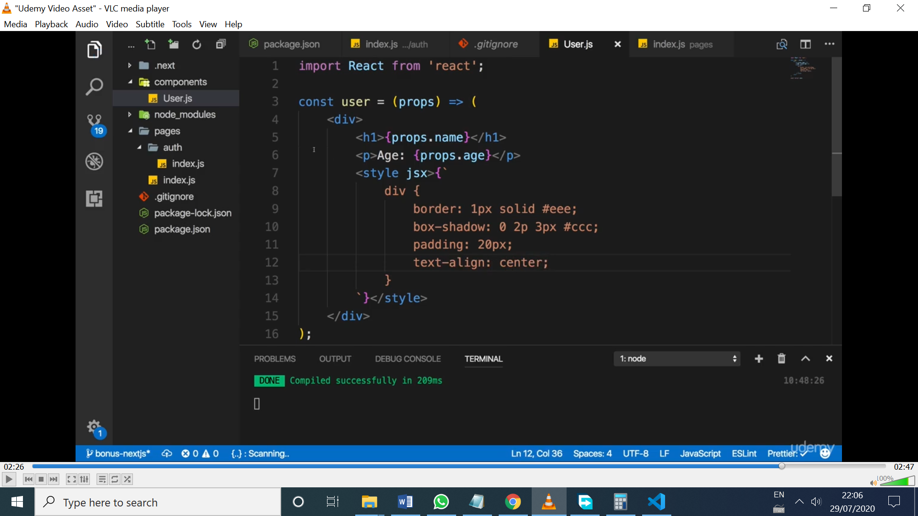
* Css modules work as usual
* Handle 404? Create _error.js file with a component
* The app needs some data for data sometimes, to render the html, so getInitialProps can be used to cause side effects, and look for that data in the server and get the html prerendered with the data we want

//for class based components

static async getInitialProps(context) {

        console.log(context);

        return {}

    }

* Example

 static async getInitialProps(context) {

        console.log(context);

        //await some http call or

        const promise = new Promise((resolve,reject) => {

            setTimeout(() => {

                resolve({

                    appName: 'super App'

                })

            } , 3000)

        });

        return promise;

    }

 render() {

        return (

            <div>

                <h1>The main page of {this.props.appName}</h1>

* Now, it takes 3 seconds for the server to return the page prepopulated with the appName

//functional components

const authIndexPage = (props) => {

    return (

        <div>

            <h1 className={classes.AuthIndexPage}>The auth page of {props.appName}</h1>

            <User name="Max" age={28}/>

        </div>

    )

}

authIndexPage.getInitialProps = (context) => {

    console.log(context);

    //await some http call or

    const promise = new Promise((resolve,reject) => {

        setTimeout(() => {

            resolve({

                appName: 'super App Auth Page'

            })

        } , 3000)

    });

    return promise;

}

* How to deploy it? Upload the whole project, not just /dist folder, because, the server needs the whole project to run it on node and serve the app, and then run npm i and npm start, and the server will run the next app on node

Section 24- Animations

transition: all 300ms ease-out;

}

.ModalOpen {

    display: block;

    opacity: 1;

    transform: translateY(0);

}

.ModalClosed {

    display: none;

    opacity: 0;

    transform: translateY(-100%);

}

* Doesn’t work because the change in display property prevents the transition
* The display property can’t be transitioned
* Solution? Remove the display in both clases
* For modals, the transition is the best solution, even over animations
* Animations gives a finer control over the steps
* By default, the animation final state will be the initial one, so to keep the final step, add ‘forwards’

.ModalOpen {

   animation: openModal 0.5s ease-out forwards;

}

@keyframes openModal {

    0% {

        opacity: 0;

        transform: translateY(-200%);

    }

    50% {

        opacity: 1;

        transform: translateY(40%);

    }

    100% {

        opacity: 1;

        transform: translateY(0);

    }

}

* Limitations of animations and transitions: the modal and backdrop are always in the DOM, rendered, but with opacitiy 0 and displaced when closed
* Bad for accessibility and slows down the app
* The OTHER APPROACH is to render the modal and backdrop conditionally

  {this.state.modalIsOpen ? <Modal show={this.state.modalIsOpen} closed={this.closeModal}/> : null}

  {this.state.modalIsOpen ? <Backdrop show={this.state.modalIsOpen}/> : null}

The when showing the modal, the animation happens, but when I close it, it DOESN’T, because the backdrop and modals are removed from the DOM

* So, the limitation is ANIMATING when REMOVING things from the DOM.
* Npm I react-transition-group to add elements added or removed from the DOM
* The ‘in’ property decides to render or not the wrapped component
* Timeout defines the length of the transition between entering to entered and exiting to exited state.
* So transition has an internal variable (state) which is entering, entered, exiting or exited, and looking at the value of that variable, I can internally style the component.

 <Transition

        in={this.state.showBlock}

        timeout={1000}

        mountOnEnter //to mounted if in is true at the beginning

        unmountOnExit>

          {state => (

             <div

             style={{

               backgroundColor: 'red',

               width: 100,

               height: 100,

               margin: 'auto',

               transition: 'opacity 1000ms ease-out',

               opacity: state === 'exiting'? 0 : 1 //react waits for this transition, and the removes it from the DOM

             }}>

             </div>

          )}

</Transition>

Other option is to always render Modal, but its content is conditionally rendered and animated with transition, like this:

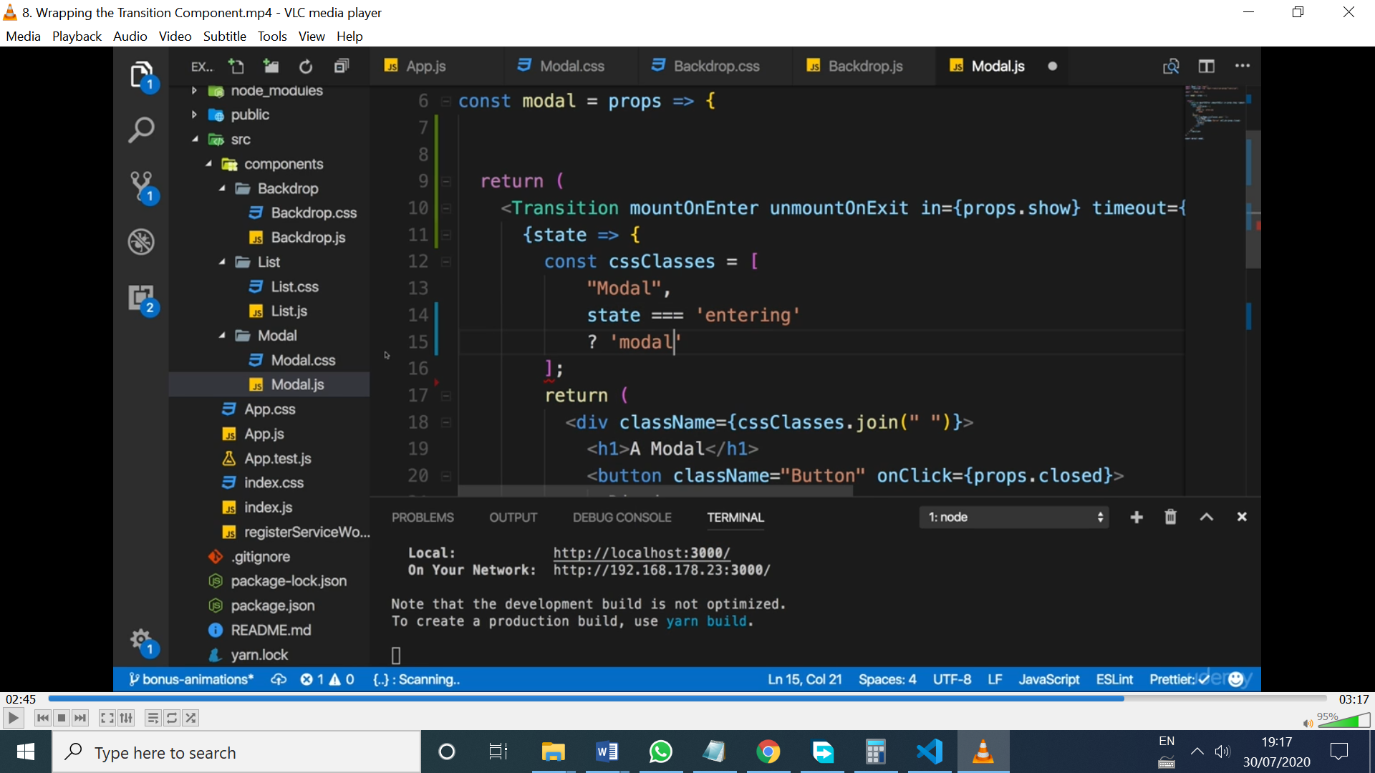

* Check transition or animation times and compare it to timeout (from <Transition>), to let the animation happens before the component is unmounted
* Enter and exit times can be different:

const animationtiming = {

  enter: 400,

  exit: 1000

}

* Wanna execute code during the transition steps? There are 6 event listeners

 onEnter={() => console.log('onEnter')}

        onEntering={() => console.log('onEntering')}

        onEntered={() => console.log('onEntered')}

        onExit={() => console.log('onExit')}

        onExiting={() => console.log('onExiting')}

        onExited={() => console.log('onExited')}

* Wanna add classes to each state automatically? Use <CssTransition> instead

The CssTransition should be placed inside the Modal.js file, to access the classes defined in the Modal.css file

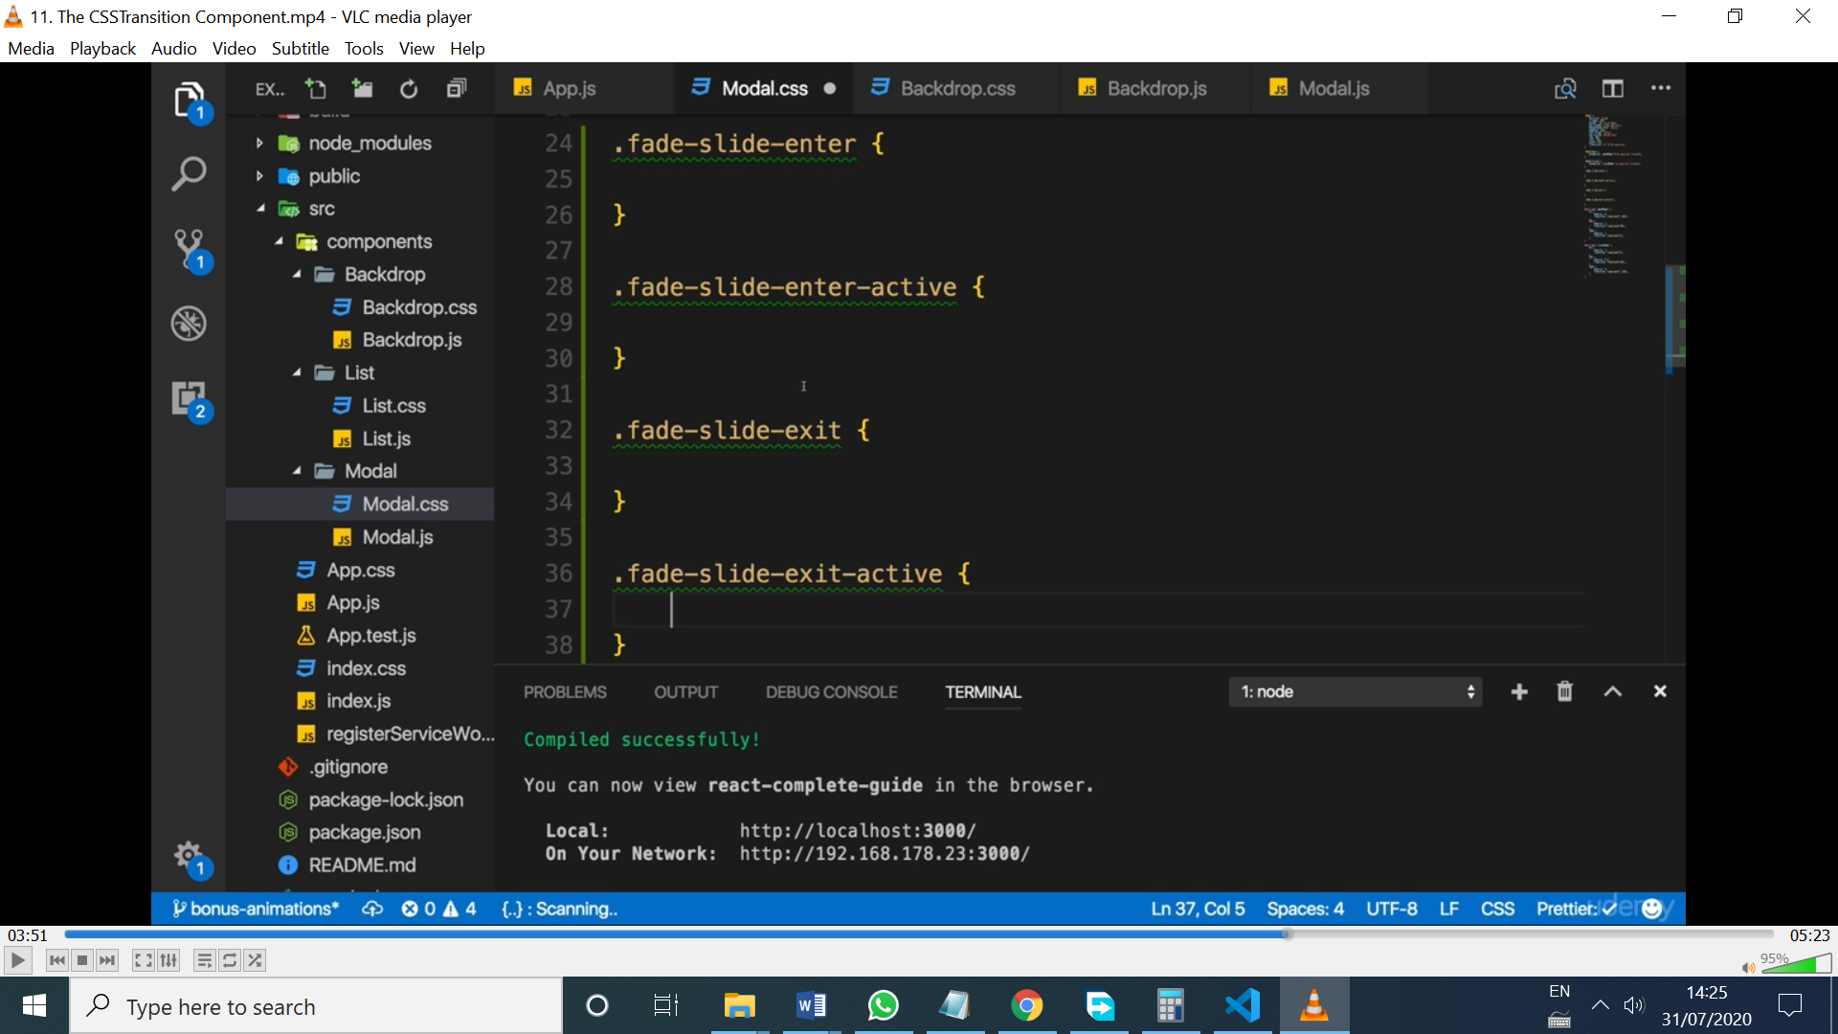

* The state anonymous function is not used anymore, and the classes will be applied to the outermost element wrapped by the <CssTransition> component
* Fade-slide-enter|exit will be removed, so they can be used for initialization. The active ones are used for the animation itself
* 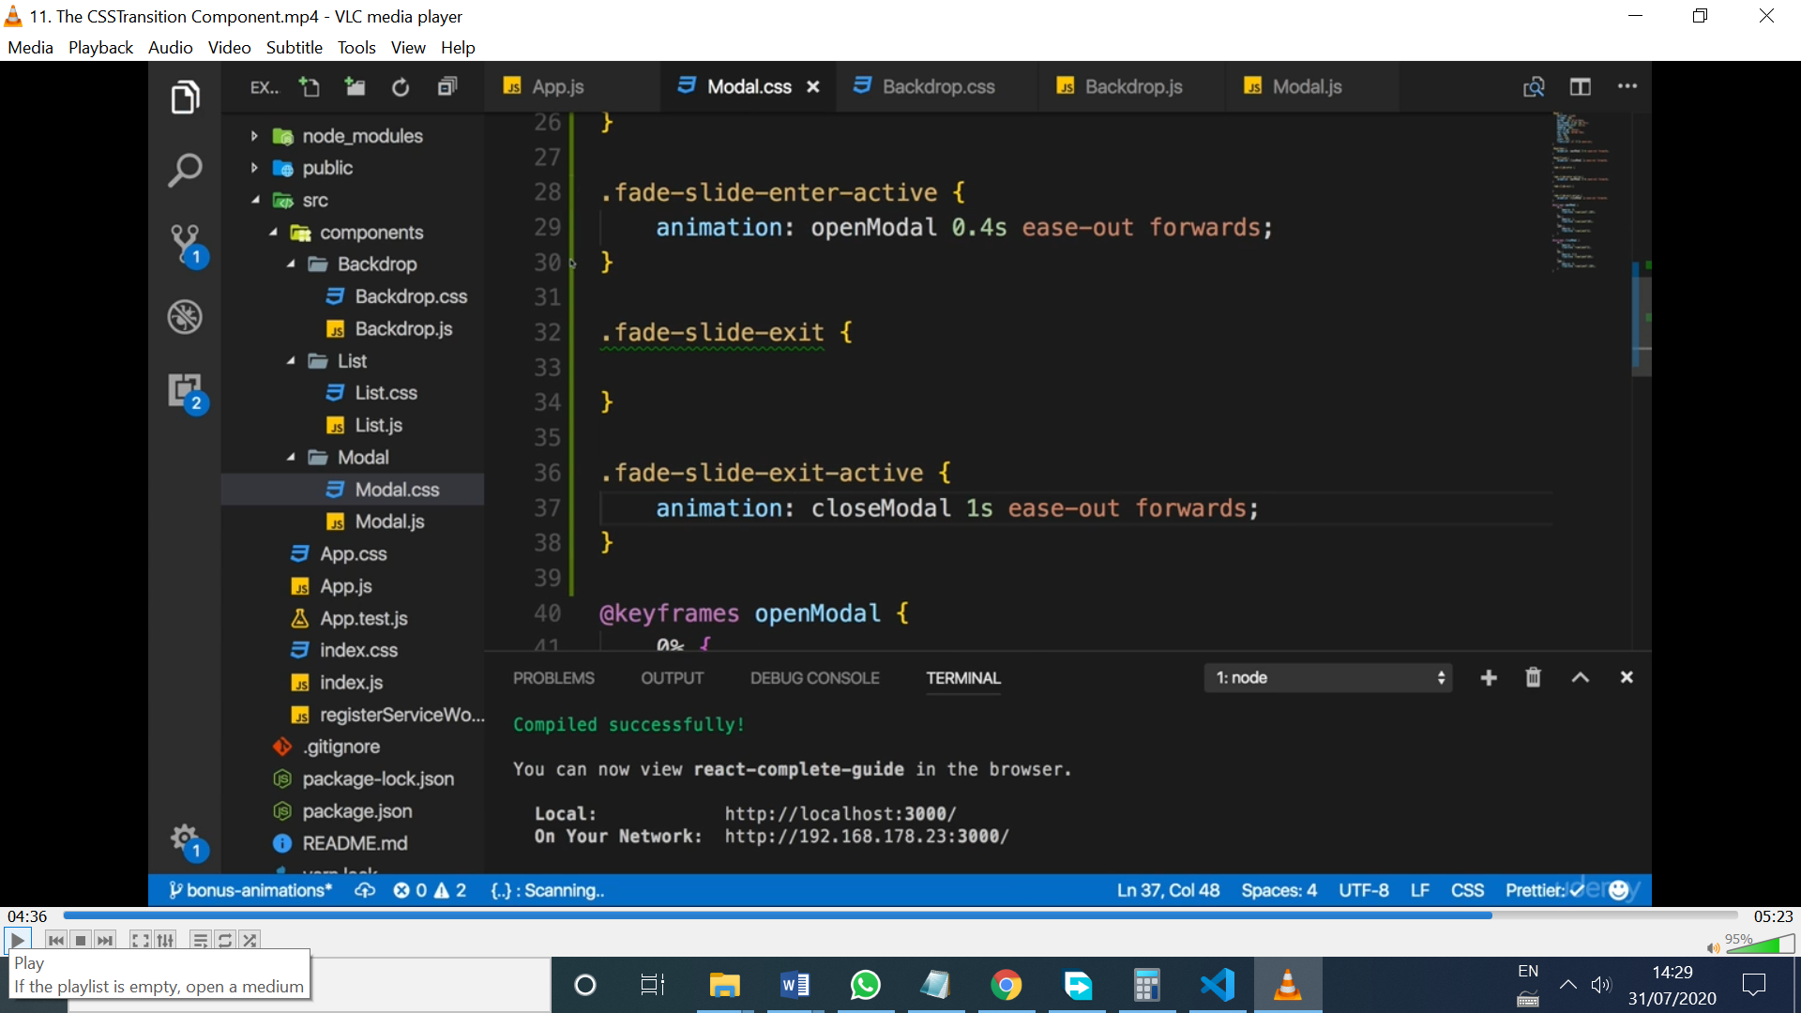
* I got rid of all the logic to assign classes based on the state, and joining them
* Wanna use custom classes names? Like ModalOpen, ModalClosed?

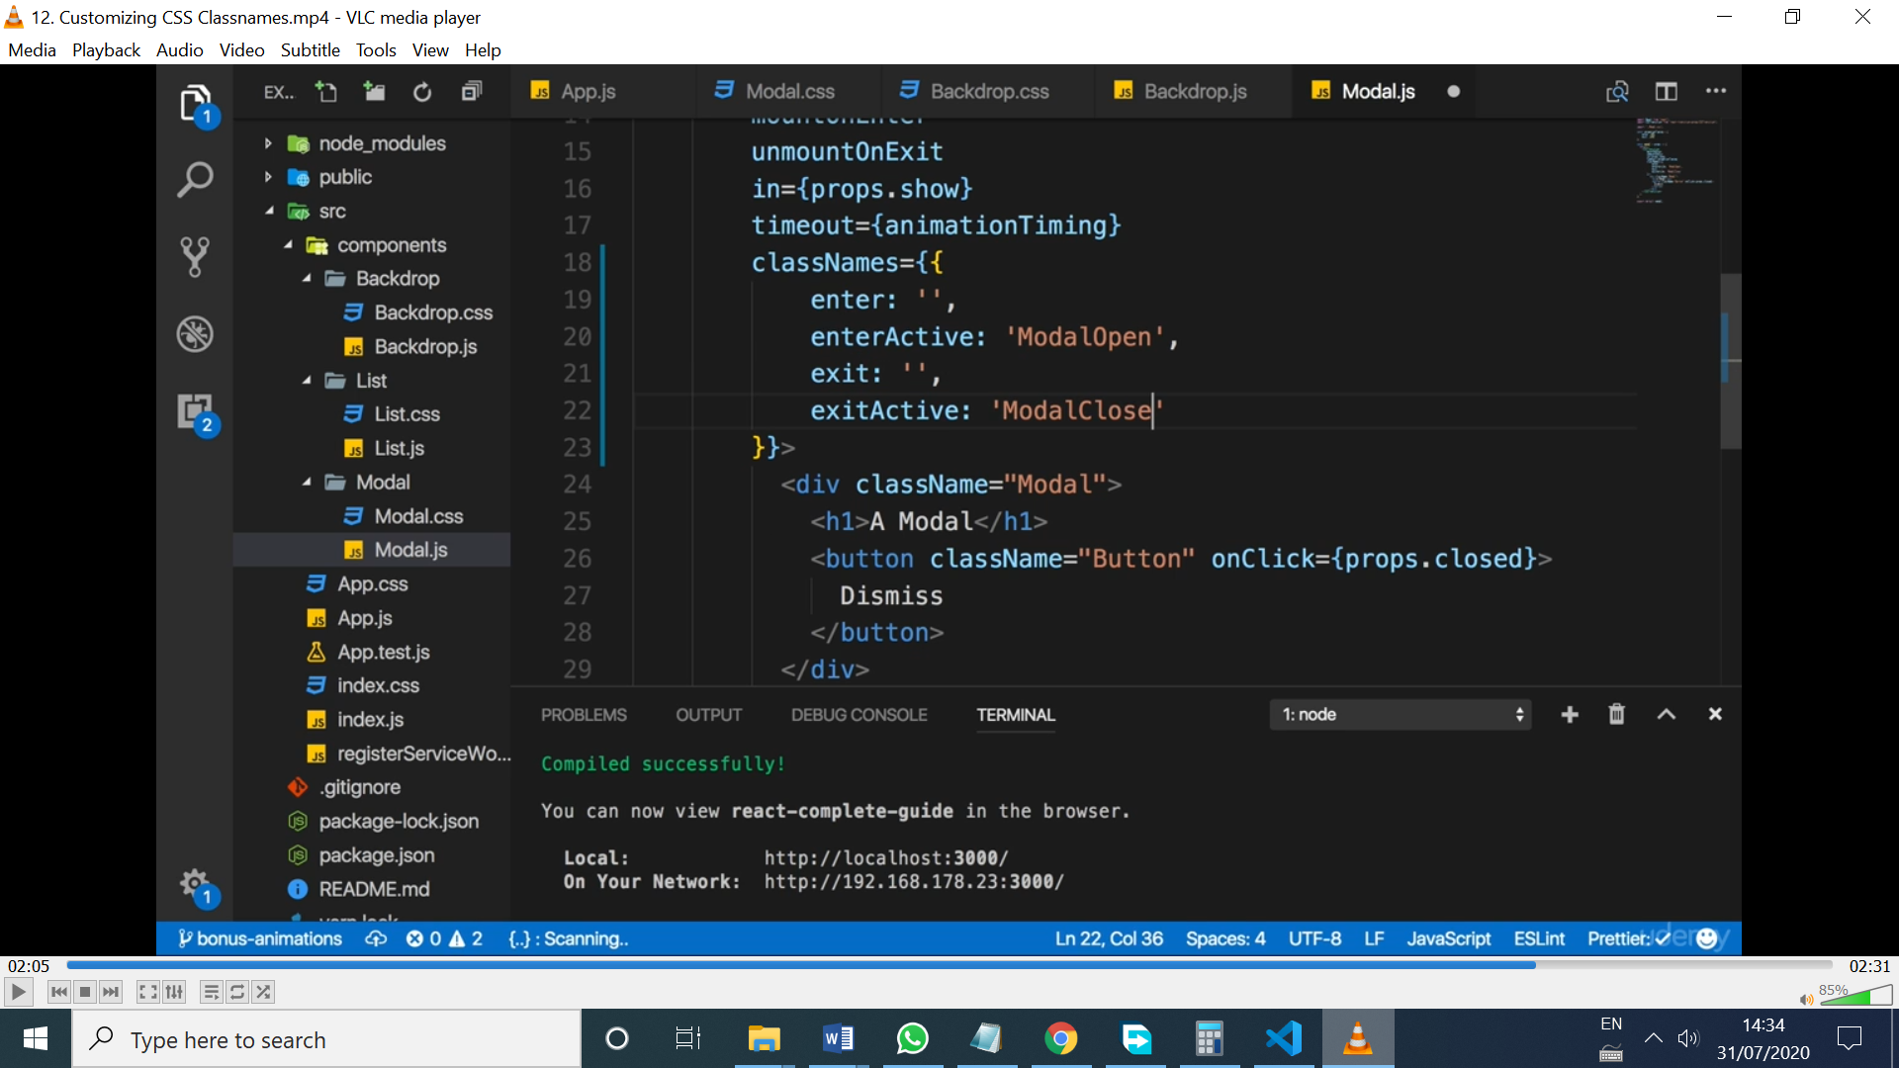

* wanna animate lists? Use TransitionGroup
* When using TransitionGroup to wrap and element, it adds a <div> by default that can be changed with component=”ul”
* The TransitionGroup watch out the list inside, and automatically manages the ‘in’ property of the list elements for us
* Use TransitionGroup for the <ul> and CssTransition wrapping the <li> elements
* Wanna add route trasitions? Use npm react-router-transition

Section 25- Redux-saga

* Sagas are kind of functions (function*) to handle side effects, called generators. Are next gen js features. They can be executed and make the function wait for it when adding yield

//before using sagas

export const logout = () => {

    localStorage.removeItem('token');

    localStorage.removeItem('expirationDate');

    localStorage.removeItem('userId');

    return {

        type: actionTypes.AUTH_LOGOUT

    }

}

//with sagas in /sagas folder

Export function* logout(action) {

    yield localStorage.removeItem('token'); //yield is like await

    yield localStorage.removeItem('expirationDate');

    yield localStorage.removeItem('userId');

    yield put ({

        type: actionTypes.AUTH_LOGOUT

    })

}

//sagas/index.js

import { takeEvery } from 'redux-saga/effects';

import { logoutSaga } from './auth';

import * as actionTypes from '../actions/actionTypes';

export function* watchAuth() {

    yield takeEvery(actionTypes.AUTH_INITIATE_LOGOUT, logoutSaga);

}

/index.js

const sagaMiddleware = createSagaMiddleware();

const composeEnhancers = process.env.NODE_ENV === 'development' ? window.__REDUX_DEVTOOLS_EXTENSION_COMPOSE__ : null || compose;

const store = createStore(rootReducer, composeEnhancers(

    applyMiddleware(thunk, sagaMiddleware)

));

sagaMiddleware.run(watchAuth);

* How to hook up the generator to the store?
* The downside is that I had to create another action, and add more folders.
* watchAuth listens for AUTH_INITIATE_LOGOUT actions being dispatched and then run the saga.
* The put() call in the generator can be replaced for a call to an action creator, like

 yield put(actions.logoutSucced());

It’s not that difficult: now, every action creator just returns an action, they’re all clean, and the sagas have the side-effect code. And new actions must be created in actionTypes.js. The index.js file in sagas decides which sagas run for each action. Sorted

Yield is not needed in localStorage API calls. Don’t overuse it

* Thunk was used to return dispatch in the action creator, but with Sagas, they’re not needed anymore! ☺
* The ‘all’ method can run code inside it concurrently (at the same time), so I could make a couple of http requests at the same time and save time.

Section 26- Hooks

* In useState hook the state can be anything, not just an object, like in class based components. It returns an array with 2 elements : the 1st is the current state snapshot, and the 2nd is a function that allows you to update that state
* The result of calling the hook can be stored like this:

 const inputState = useState({title: '', amount: ''})

* useState just overrides the previous state, doesn’t merge it!!
* An option to merge the state could be

 <input

            type="text"

            id="title"

            value={inputState[0].title}

            onChange={event => inputState[1]({...inputState[0], title: event.target.value})}/>

* But the current snapshot is not reliable, and is 100% guaranteed is the latest one
* To get the latest state, pass a function to inputState[0]

 onChange={event => inputState[1]((prevState) => ({...prevState, title: event.target.value}))}/>

* The event should be stored in a constant, to avoid an error, because react reuses event object in the inner function, so it’s better to assign a new one on a constant everytime

onChange={event => {

                const newTitle = event.target.value; //save event, in the outer scope of the function below

                inputState[1](prevState => { //an inner function, a closure

                  return {

                    ...prevState,

                    title: newTitle

                  }

                })

              }

            }/>

* Using array destructuring, there’s a cleaner syntax

const [inputState, setInputState] = useState({title: '', amount: ''})

value={inputState.title}

onChange={event => {

                const newTitle = event.target.value;

                setInputState(prevState => {

                  return {

                    ...prevState,

                    title: newTitle

                  }

                })

              }

            }/>

* If you don’t wanna spread the prevState in your new state, it’s better to use as many hooks as properties you wanna store

const [enteredTitle, setEnteredTitle] = useState('');

const [enteredAmount, setEnteredAmount] = useState('');

value={enteredAmount}

            onChange={event => {

              setEnteredAmount(event.target.value);//avoided closure

            }

* Only use objects or arrays inside useState if required, otherwise, just use strings, Booleans, etc
* If you want to have null or undefined as initialState, you don’t pass any arguments to useState()
* RULE #1 use hooks inside hooks at their root level or at the root level of a functional components, not inside functions (e.g sumbitHandler()), not even inside if statements
* Wanna cause side-effects ?? use useEffect which runs efter every render cycle ;) (if no array arguments is passed)
* How to avoid re-running useEffect in every cycle. Passsing an array to useEffect with the dependancies
* With empty array, useEffect is like componentDidMount()
* Modify the database rules to alow filtering in the hooks project
* [enteredFilter, onLoadIngredients] the dependancies array
* This setup causes an infinite loop, because onLoadIndredients point to a function inside Ingredients.js, and that function is created (not executed) everytime the ingredient component re-renders
* To avoid the infinite loop, wrap the function with useCallback function, to cache that function and not recreate every time the functional component re-renders
* Sending an http request with every keystroke is no ideal, it’s better to set a timer and send the request if the old and the new enteredFilter are different
* To access the current value of the input, it can be accessed with a local ref
* Important note about cleanup in useEffect: if [] was passed as an argument, cleanup function runs when the before the component is unmounted
* Tired of writing props.some ? <SomeCOmponent> : null ????
* Type props.some && <SomeCOmponent>
* React batches setState()’s in batches to avoid innecesary re-renders of component, changing states.

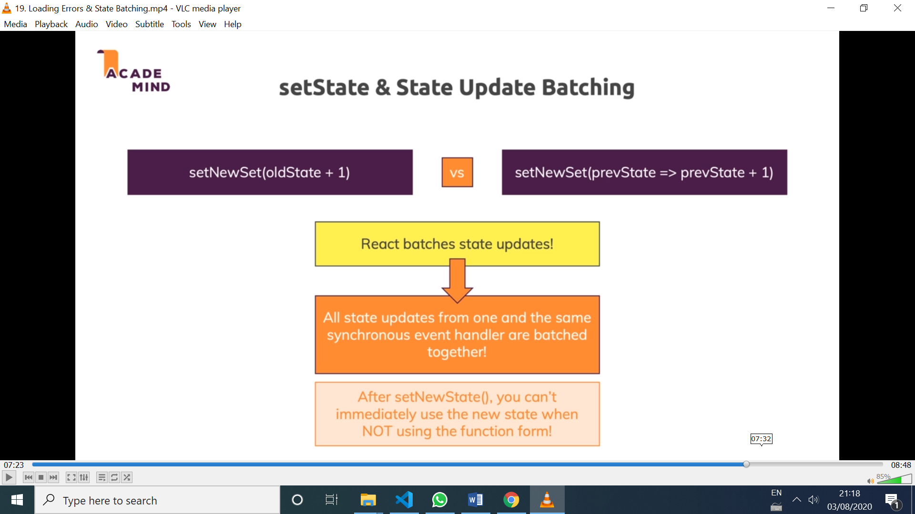

.catch(error => {

      setIsLoading(false);

      setError(error.message);

    })

//this 2 setState methods are batched together

* If setIngredients is called and used for updating the ingredients in different way (set, add, delete), a reducer can be the answer, to avoid calling setIngredients every time with the logic needed to update the state the way we want (e.g add ingredients, or delete ingredients)

// setIngredients((prevIngredients) => {

      //   return prevIngredients.filter(ingredient => ingredient.id !== ingredientId);

      // })

VS

dispatch({type: 'DELETE', ingredientId: ingredientId});

* When using useReducer, the reducer is set outside the component function, so it doesn’t have to be recreated for every rendering cycle
* useReducer() return an array with the current state, and a function to change it
* React will re-render when the reducer returns a new state
* Another scenario to use reducers is when there is a state connected to each other, like loading and error in an http call
* Instead of managing the auth logic in the root level, it’s better to have the logic in the Auth component, and keep the auth state with the context API.
* App optimization: avoiding unnecessary re-renders

Ingredien.js

<IngredientForm onAddIngredient={addIngredientHandler} isLoading={httpState.loading}/>

//passing a function as a props, means that every time the Ingredient component re-renders, addIngredientHandler is recreated and IngredientForms ir re-render. Doesn’t make sense

* Even though there’s a react.memo in ingredientForm, it gets re-rendered because it’s a brand new object passed via proprs every time the parent gets re-rendered

const IngredientForm = React.memo(props => {

* The solution? Add useCallback to addIngredientHandler
* Another option to React.memo, is to use useMemo in Ingredient.js

const ingredientList = useMemo(() => {

    return <IngredientList ingredients={ingredients} onRemoveItem={removeIngredientHandler}/>

  }, [ingredients, removeIngredientHandler])

* React.memo() in NOT FOR FREE, so if the component is small, it’s better to let it re-render as much as it wants
* Custom hooks. All the hooks must be named useSomething
* The hook can use the state of the component using it, and the logic can be used in different components.
* The hook will be re-executed with every re-render, like all hooks
* When the state changes inside a hook, the component that uses that hook re-renders
* What do hooks are good for? Sharing stateful logic across components. But that state is scoped to the component is uses it, not shared across the other component which uses it.
* The same state CAN be shared across components if the state is defined outside the hook, like the useStore() custom hook of the example.

Section 27- Adding Hooks to BurgerBuilder

* To let React consider my function a Functional component, the name should start with capital letters
* To avoid converting asyncComponent.js HOC, I use React.lazy for loading the routes. So I deleted that file
* When using React.lazy(), add Suspense, and use render=() inside the Route

 <Route path="/auth" component={Auth} />

<Route path="/auth" render={(props) => <Auth {…props}/>} />

* Pass props, so the lazy loaded Components have access to props.history
* Wanna use react.memo and check for specific props?

export default React.memo(Modal, (prevProps, nextProps) => {

    return prevProps.show === nextProps.show && prevProps.children === nextProps.children;

}); returns true when we don’t wanna render it, so when both props didn’t change

* Replace the logic inside withErrorHandler HOC component (which holded the error state) and pass that logic to a hook that can have a state.
* The hook can also be imported in the components, and use that error and add or remove the Modal conditionally. It was better to keep the Modal in the withErrorHandler HOC to not DRY (using the modal in every component that wants to catch errors)
* With Redux > version 7, the connect API can be replaced with useDispatch and useSelect, to replace mapStateToProps and mapDispatchToProps
* useSelector will give the current state snapshot

Section 28-Replacing Redux with Hooks

* option 1: Context API
* Create the context and use a functional component with useState to manage the state, and pass provide the products and setProducts
* Is NOT optimal for high frequency changes, like in the example, because every component that uses that context will re-render. Good for managing themes or authentication (I wouln’t use it. I’d prefer a high performant central store)
* Option 2: Hooks
* useState is used inside the custom hook. So, when the state changes by using setState, the component using the custom hook will re-render
* globalState defined OUTSIDE of the hook. So now, the state is the same for all components using the custom hook. NOW, DATA and LOGIC are shared across components
* every component that uses the custom hook, will add one setState instance to listeners array
* when each component is unmounted, that setState pointer should be removed from listeners array
* ProductItem re-renders when the state is updated, even when another product was changed. To avoid this, the useStore hook can take an argument (Boolean) to let the hook decide to register that setState pointer ;)

Section 29 –Burger CSS

* The bread has position: relative, so the position:absolute of seeds refer to it
* Once once seed was create, other 2 can be created with after and before pseudo selectors
* For these last 2 seeds, all the percentages references to the original seed